Paper title:
Chromatic pupillary reflex as a screening tool for Type 2 Diabetes Mellitus Diagnosis
Authors:
1- Eduardo Nery Rossi Camilo
Universidade Federal de São Paulo / Fundação Banco de Olhos de Goiás
2- Cleyton Rafael Gomes Silva
Universidade de Goiás – Goiânia
3- Cristhiane Goncalves
Universidade de Goiás – Goiânia
4- Ronaldo Martins da Costa
Universidade de Goiás – Goiânia
5- Celso Goncalves Camilo Junior
Universidade de Goiás – Goiânia
6- Nelson Rassi
Hospital Alberto Rassi – HGG – Goiânia
7- Augusto Paranhos Junior
Universidade Federal de São Paulo – São Paulo

Corresponding author
Av. T-13, numero 796 – St Bueno, Goiania, Goias – CEP: 74230-050

Key words
Chromatic pupillary reflex; Diabetes Mellitus, Type 2; Artificial Intelligence

Abstract
Approximately 50% of people with diabetes remain undiagnosed, especially in developing countries, until the onset of clinical complications. To develop an automated pupilometry system (SAP) to diagnosis of type 2 diabetes based on the pupillary reflex.
A pupilometer with a lighting system was used with external lighting sealing. While the RGB LED lighting system offers a solution for a pupil response, an infrared camera captures it as images. To evaluate the direct pupil reflex, the pupilometer was used to record videos during stimuli with a luminance of 250 cd / m2 and 1 second of duration after the patient was adapted to the dark for 10 minutes. The interval between stimuli was of 59 seconds. After a data capture, a data processing phase, data return declaration and data normalization were applied. In the last phase, a learning machine algorithm, called Random Forest, was applied to create the classification model of patients. The patients were classified in groups: Group 1 – Healthy, Group 2 – Type 2 Diabetes. All patients underwent complete ophthalmologic consultation and macular OCT. Thus, the patients were according to the diagnosis of the type2 diabetes based on the American Diabetes Association. The study was approved by the Institutional Review Board CAAE: 23723213.0.0000.5083.
Automated pupilometry system was able to record, induce, and extract 96 pupil features. 31 volunteers were analyzed (16 in Group 1, 15 in Group 2), of which 22 were female volunteers (70.97%) and 9 were male volunteers (29.03%). A mean age of 60 year. As a result of the automated classification, Random Forest presented a result of 94.0% accuracy in the identification of diabetics type II was obtained.
The present results are consistent with previously published studies, showing that diabetes is associated with dysregulation of the autonomic system, The proposal proved to be promising, noninvasive, objective and portable method of identifying the Type 2 Diabetes.

Introduction and justification:
Type 2 diabetes mellitus affects about 366 million people worldwide ^{1.2}, approximately 80% of these people live in low and middle income countries. Approximately 50% of people with diabetes remain undiagnosed^{1,3,4} , especially in developing countries, until the onset of clinical complications. An early complication of diabetes is autonomic dysfunction^{1.5}, which is often subclinical.
Pupillometry is a non-invasive and rapid research method for assessing the autonomic system, which has the potential to improve screening and its complications, without the need to obtain a blood test or multiple screening tests for autonomic cardiac dysfunction. .^{1,6} The pupillary reflex is mediated by acetylcholine and norepinephrine, causing miosis and mydriasis, respectively. ^{1,6-8} Thus, changes in pupillary responses to external light may provide an indirect means of screening for type 2 diabetes, distinguishing individuals with and without diabetes.

Materials and Methods:
Prospective study involving 31 patients from two groups: Group 1 - 16 healthy volunteers; Group 2 - 15 type II diabetic volunteers. All patients underwent endocrinological and ophthalmological evaluation. All assessments were standardized, as recommended by the American Diabetes Association. In the ophthalmological evaluation, visual acuity, refraction, intraocular pressure, biomicroscopy (cataracts), fundoscopy (diabetic retinopathy and glaucoma), angiography retinography in diabetic patients and without angiography in patients without diabetes, macular OCT were measured.
Inclusion criteria: Patients aged 40-75 years, who were eligible for inclusion in the study and provided consent.
Exclusion criteria: Patients with neurological diseases, such as Grave's disease, Parkinson's disease, Alzheimer's disease or multiple sclerosis; or ocular complications were excluded from the study, as these conditions may interfere with the proper interpretation of pupillometry results. Ophthalmic exclusion criteria included: best corrected visual acuity less than 0.2 logMAR; lens opacity greater than 0.5, according to the Lens Opacity Classification System III (LOCS III); corneal, orbital or retinal changes, including diabetic retinopathy; asymmetric pupils, misshapen pupils or conditions that affect pupillary reflexes and previous ophthalmologic surgeries. Individuals were also excluded if they had a spherical refractive error greater than 5D or a cylindrical error greater than 3D or if they were unable to cooperate during psychophysical tests.
Pupillary Light Reflex Test Stimuli
The protocol used to measure the response to a pupillary stimulus was based on a method previously used by Gracitelli et al.⁹ The light stimulus and pupillary recording were monocular. The patient was first adapted to the dark for 10 minutes. Then, RGB LEDs, with a luminance of 250 cd / m2, were exposed to the patient. Red LED (640nm) was presented with a duration of 1 second, with monitoring for 59 seconds. Afterwards, blue (470nm), green (555nm) and white stimulus were performed respectively. Pupillometry was performed on fasting patients. Figure 1.
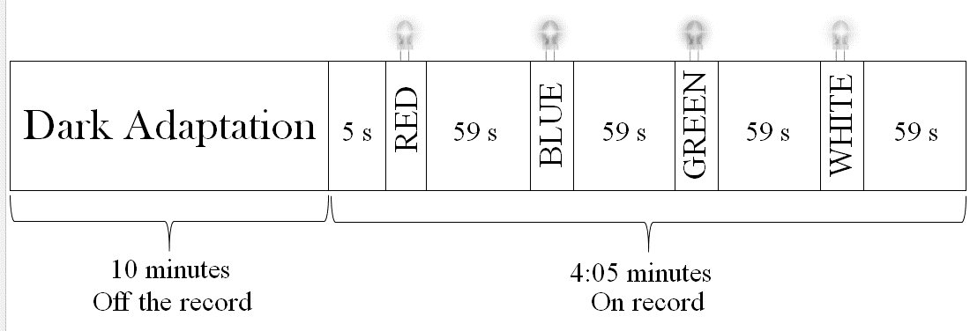
Fig. 1. Pupillometry protocol.

The signals that were decomposed by the system represent five seconds before and ten after the second where the stimulus occurs, each signal represents 16 seconds and a stimulus color. Through each of these signals, the system performs the calculation and extraction of eight relevant characteristics for understanding changes in human pupillary behavior ^{10.11}, Figure 2.

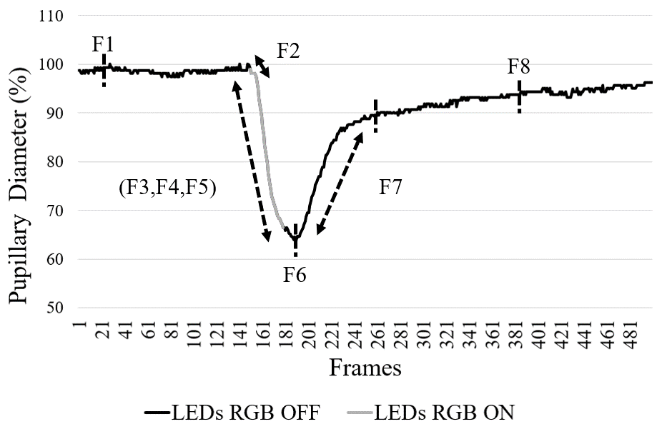
Fig. 2. Pupillary reflexes: (A) mydriases and (B) miosis.
F1. Maximum Dilatation: largest pupillary diameter recorded in the interval, usually found in the period before the beginning of the stimulus. F2. Latency: time spent in seconds between the start of the stimulus and the start of the contraction process, thus considered as a 10% change in diameter. F3. Time to Maximum Contraction: time spent in seconds between the beginning of the stimulus and the maximum value of contraction registered. F4. Relative Contraction Amplitude: percentage value of the difference between the largest and the smallest diameter. F5. Absolute Contraction Amplitude: absolute value of the difference between the pupillary diameter before the stimulus and the value of the maximum contraction. F6. Maximum Contraction: smallest diameter recorded in the interval, normally found during the stimulus. F7. Post-stimulus dilation speed: time in seconds that the pupillary diameter takes after the stimulus to reach 85% of the previous value. F8. Six-second Test: diameter recorded 6 seconds after the end of the stimulus.

Results:
Were selected 31 patients, 15 diagnosed with type II diabetes mellitus and 16 healthy to form the control group.
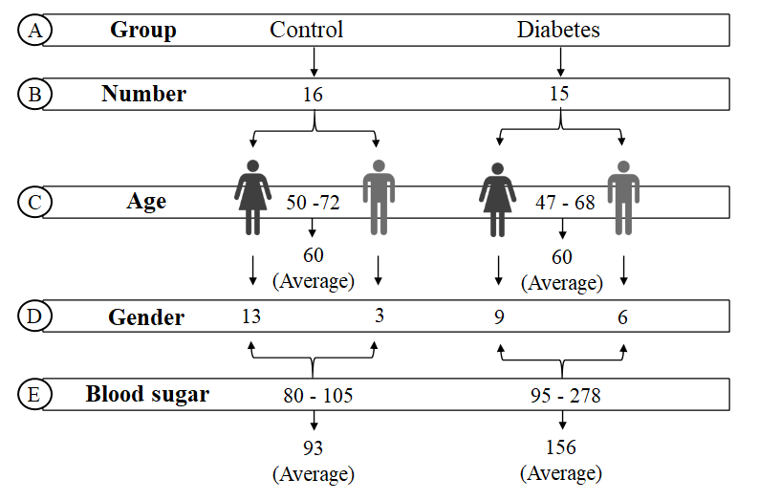
Fig. 3. Participants description: (A) Group (control, diabetes), (B) Number, (C) Age range and average, (D) Numbers by gender (female, male) and (E) Range and average of blood sugar.
Through Figure 3 can be seen that the volunteers are mostly women, and that both groups have an average age of 60 years, a relevant factor, considering that pupil behavior differs depending on the age group ¹². All of them went through the procedure of pupilometry in fasting and during the morning. The capillary glucose level was measured before each procedure, the control group had a regular level ¹³, with an average below 93mg / dl, while the diabetic group had a high level, with an average of 156 mg / dl.
For the analysis and classification of data, the Weka platform in version 3.8.2 was used. The characteristics of each patient were converted into the ARFF format for processing at Weka and had their labels assigned as "Control" or "Diabetes", forming the dataset. After building the dataset, the OneR classifier was used. OneR or 1R is a classifier that aims to build a predictive model from just one characteristic, the one whose rule has the lowest error rate ¹⁴. Since all values in the dataset are numeric, the algorithm needs to convert the range of possible values into subintervals called bins or buckets. The 1R selection filter was applied using Weka's attributeSelection library, with the following parameters: 6 for the minimum bucket size and 10 folds for cross-validation. For the purpose of this research, the characteristics that demonstrated greater accuracy, above 60%, were selected.
In order to build a predictive model to support the investigation of type II diabetes mellitus, the selected characteristics used for training the algorithm known as Random Forest. The choice of how the decision tree will be divided into nodes takes place in order of relevance for each characteristic, in this stage several selection techniques can be used, such as: Information Gain, Gini Index, Likelihood-Ratio Chi-Squared Statistics and others ¹⁵. While the decision of the thresholds for the conditions of the nodes considers the threshold that best divides the objects of the dataset in their respective class labels.
Using the Weka platform, the dataset built by extracting the characteristics was used to train a random forest. The minimum number of trees for the best performance of the model was 75 trees. For model reapplicability, the number of random seeds was set to 2. In the validation of the model, k-fold cross validation was used, this type of validation partitions the data into k equally sized (or almost equally) folders.
In validating the model, a 10-fold k-fold validation was used. Through the confusion matrix, it was noticed that only 1 diabetic was incorrectly classified, which led the approach to achieve 94% accuracy when identifying diabetics, while 3 control patients were classified as diabetic, which can be analyzed by through the ROC curves.

Discussion:
In this research an Automated Pupilometry System (SAP) was used, whose segmentation has an accuracy of 97.25% in the tests. This factor allowed the system to be able to extract 8 important characteristics of pupil behavior in each type of stimulus, totaling 96 characteristics relevant to medical analysis. Due to the ease of identifying pupil size and movement, many studies have attempted to evaluate different pupil parameters and link these results to the clinical course of autonomic neuropathy ^{8,17,18} Alzheumer ¹⁹, Brain injuries ²⁰, Glaucoma ⁹, Autism ^{21.22}, Parkinson ²³. As far as we know, this study is one of the first to describe and investigate changes in the behavior of the pupillary reflex in diabetic patients.
The present results are consistent with previously published studies, showing that diabetes is associated with dysregulation of the autonomic system^{1.5}. Recent studies indicate that short-term changes in blood glucose concentration may influence the function of the autonomic system. In patients with Insulin Dependent Diabetes Mellitus (IDDM), gastric emptying is slower during hyperglycemia than during euglycemia ^{24,25} and more accelerated during hypoglycemia.^{24,26} In normal individuals the secretion of pancreatic polypeptides is suppressed by acute hyperglycemia, consistent with a reduction in vagal activity.^{24,27} In patients with IDDM, acute hyperglycemia delays the conduction speed of peripheral nerves.^{24,28} In acute hyperglycemia, an increase in the QT interval has been demonstrated in normal individuals and in patients with recently diagnosed type 2 diabetes. Among the mechanisms proposed to explain this finding, sympathetic stimulation without opposition by vagal activity induces ventricular electrical instability.²⁹⁻³¹

Conclusion: This result made it possible to highlight the potential of the SAP system in supporting the investigation of patients with type II diabetes mellitus. Thus, in the future, SAP can become a useful tool for an earlier and preventive medical diagnosis, as well as for investigating other pathologies. The SAP system is a portable and efficient pupillometry solution for extensive practices in medical and research investigations. This system also represents a segment of a larger health information system, where the goal is for health institutions to become collection points for pupillary characteristics of patients with neurological diseases and contribute to increasing their accuracy.

Bibliography:
1. Thayer JF, Sternberg E. Beyond heart rate variability: vagal regulation of allostatic systems. Annals of the New York Academy of Sciences. 2006;1088:361-72.
2. Bar KJ, Schulz S, Koschke M, Harzendorf C, Gayde S, Berg W, et al. Correlations between the autonomic modulation of heart rate, blood pressure and the pupillary light reflex in healthy subjects. Journal of the neurological sciences. 2009;279(1-2):9-13.
3. Bremner FD, Smith SE. Pupil abnormalities in selected autonomic neuropathies. Journal of neuro-ophthalmology: the official journal of the North American Neuro-Ophthalmology Society. 2006;26(3):209-19.
4. Bremner F, Smith S. Pupil findings in a consecutive series of 150 patients with generalized autonomic neuropathy. Journal of Neurology, neurosurgery, and psychiatry. 2006;77(10):1163-8.
5. Ferrari GL, Marques JL, Gandhi RA, Heller SR, Schneider FK, Tesfaye S, et al. Using dynamic pupillometry as a simple screening tool to detect autonomic neuropathy in patients with diabetes: a pilot study. Biomedical engineering online. 2010;9:26.
6. Pittasch D, Lobmann R, Behrens-Baumann W, Lehnert H. Pupil signs of sympathetic autonomic neuropathy in patients with type 1 diabetes. Diabetes care. 2002;25(9):1545- 50.
7. Lerner AG, Bernabe-Ortiz A, Ticse R, Hernandez A, Huaylinos Y, Pinto ME, et al. Type 2 diabetes and cardiac autonomic neuropathy screening using dynamic pupillometry. Diabetic medicine: a journal of the British Diabetic Association. 2015;32(11):1470-8.
8. Zangemeister WH, Gronow T, Grzyska U. Pupillary responses to single and sinusoidal light stimuli in diabetic patients. Neurology international. 2009; 1 (1): e19.
9. GRACITELLI, CPB; DUQUE-CHICA, GL; MOURA, AL; NAGY, BV; DE MELO, GR; ROIZENBLATT, M .; BORBA, PD; TEIXEIRA, SH; VENTURA, DF; PARA- NHOS, A. A positive association between intrinsically photosensitive retinal ganglion cells and retinal nerve fiber layer thinning in glaucoma. Investigative Ophthalmology and Visual Science, 55 (12): 7997–8005, 2014.
10. ADHIKARI, P .; ZELE, AJ; FEIGL, B. The post-illumination pupil response (PIPR). Investigative Ophthalmology and Visual Science, 56 (6): 3838–3849, 2015
11. PINHEIRO, H .; NERY, E .; CAMILO, R .; DA COSTA, R. Methodology and Portable Device for Assessment of Pupillary Reflex. Twenty-first Americas Conference on Information Systems, Puerto Rico, 2015, p. 10, 2015.
12. KOHNEN, EM; ZUBCOV, AA; KOHNEN, T. Scotopic pupil size in a normal pediatric population using infrared pupillometry. Graefe 's archive for clinical and experimental ophthalmology, 242 (1): 18–23, 1 2004.
13. SOCIEDADE BRASILEIRA DE DIABETES. Diretrizes da Sociedade Brasileira de Diabetes 2017-2018. Editora Clannad, São Paulo, 2017 edition, 2017.
14. NEVILL-MANNING, C .; HOLMES, G .; WITTEN, I. The development of Holte's 1R classifier. Proceedings 1995 Second New Zealand International Two-Stream Conference on Artificial Neural Networks and Expert Systems, 1995.
15. ROKACH, L .; MAIMON, O. Decision Trees. Data Mining and Knowledge Discovery Handbook, p. 165–192, 2010.
16. MUDRY, A .; TJELLSTRÖM, A. Historical background of bone conduction hearing devices and bone conduction hearing aids. Advances in Oto-RhinoLaryngology, 71: 1–9, 2011.
17. Deli G, Bosnyak E, Pusch G, Komoly S, Feher G. Diabetic neuropathies: diagnosis and management. Neuroendocrinology. 2013;98(4):267-80.
18. Schwingshandl J, Simpson JM, Donaghue K, Bonney MA, Howard NJ, Silink M. Pupillary abnormalities in type I diabetes occurring during adolescence. Comparisons with cardiovascular reflexes. Diabetes care. 1993;16(4):630-3.
19. FOTIOU, F .; FOUNTOULAKIS, KN; TSOLAKI, M .; GOULAS, A .; PALIKARAS, A. Changes in pupil reaction to light in Alzheimer's disease patients: a preliminary report. International Journal of Psychophysiology, p. 111–120, 2000.
20. BRACCO, F .; STUDENT, I .; DI, C .; STUDENT, VI; CERINA, L .; MEMBER, I .; SANTAM-BROGIO, MD; SENIOR, I. BIE-PInCS: Brain Injury Evaluation with Pupillometer based on INfrared Camera System. IEEE 3rd International Forum on Research and Technologies for Society and Industry (RTSI), 2017.
21. MARTINEAU, J .; HERNANDEZ, N .; HIEBEL, L .; ROCHÉ, L .; METZGER, A .; BONNET- BRILHAULT, F. Can pupil size and pupil responses during visual scanning contribute to the diagnosis of autism spectrum disorder in children? Journal of Psychiatric Research, 45 (8): 1077–1082, 2011.
22. NUSKE, HJ; VIVANTI, G .; HUDRY, K .; DISSANAYAKE, C. Pupillometry reveals reduced unconscious emotional reactivity in autism. Biological psychology, 101: 24–35, 9 2014.
23. WANG, C.-A .; MCINNIS, H .; BRIEN, DC; PARI, G .; MUNOZ, DP Disruption of pupil size modulation correlates with voluntary motor preparation deficits in Parkinson's disease. Neuropsychologia, 80: 176–84, 1 2016
24. Yeap BB, Russo A, Fraser RJ, Wittert GA, Horowitz M. Hyperglycemia affects cardiovascular autonomic nerve function in normal subjects. Diabetes care. 1996 Aug; 19 (8): 880-2.
25. Horowitz M, Fraser RJ: Disordered gastric motility in diabetes mellitus. Diabetologia 194; 37: 543-551
26. Schvarcz E, Palmer M, Aman J, Lindkvist B, Beckman KW: Hypoglycaemia increases gastric emptying rate in patients with insulin-dependent diabetes mellitus. Diabetic Med. 1993;10:660-663
27. Schwartz TW. Pancreatic polypeptide: a hormone under vagal control. Gastroentero. 1983;85:1411-1425
28. Sindrup SH, Ejlertsen B, Gjessing H, Svendsen A, Froland A. Peripheral nerve function during hyperglycemic clamping in insulin-dependent diabetic patients. Ada Neurol Scand. 1989; 79:412-418.
29. Santini V, Ciampittiello G, Gigli F, Bracaglia D, Baroni A, Cicconeti A, et al. QTc and autonomic neuropathy in diabetes: effects of acute hyperglycaemia and n-3 PUFA. Nutr Metab Cardiovasc Dis. 2007 Dec; 17 (10): 712-8.
30. Marfella R, Nappo F, De Angelis L, Paolisso G, Tagliamonte MR, Giugliano D. Haemodinamic effects of acute hyperglycaemia in type 2 diabetic patients. Diabetes Care. 2000; 23: 658e63.
31. Marfella R, Nappo F, De Angelis L, Siniscalchi M, Rossi F, Giugliano D. The effect of acute hyperglycaemia on QTc duration in healthy man. Diabetologia 2000; 43: 571e5.

