VITREOMACULAR INTERFACE AFTER ANTI-VEGF INJECTIONS IN DIABETIC MACULAR EDEMA

Abstract

Purpose: The purpose of this study is to evaluate the incidence of vitreomacular adhesion (VMA) release after anti-VEGF therapy for the treatment of diabetic macular edema (DME) and to evaluate further changes in outcome.

Methods: This is a retrospective study that enrolled 66 eyes of 66 patients with DME who presented with VMA by spectral-domain optical coherence tomography (OCT) at baseline. VMA was classified as focal (attachment: ≤ 1500 μm) or broad (attachment: > 1500 μm). All patients received at least three monthly intravitreal injections of an anti-VEGF agent. Follow-up visits were performed 1 month after each injection to evaluate the incidence of VMA release.

Results: The mean age was 61.4 years (range: 29 to 78 years) and 72.7% were male. Mean best-corrected visual acuity was 0.62 logMAR and mean central retinal thickness (CRT) was 473 μm at baseline. Mean follow-up was 18.5 months and the mean number of injections was 5.8. Intravitreal drugs used were aflibercept (40.9%), ranibizumab (37.9%) and bevacizumab (21.2%). Forty-seven eyes had broad VMA and 19 had focal VMA. Twenty-two eyes (33.3%) developed VMA release following a mean of 5.7 injections (range: 3-13). Sixteen eyes (72.7%) with focal VMA and 6 eyes (27.3%) with broad VMA at baseline developed VMA release. Twenty-one eyes that developed VMA release showed improvement in CRT following VMA release (mean: -106 μm; range: 22 to 289 μm).

Conclusion: VMA release occurs in approximately 1/3 of the patients with DME following anti-VEGF therapy. Most of them showed short-term decrease in CRT.

Introduction
Diabetic macular edema (DME) is the most common cause of visual impairment in patients with diabetes mellitus, occurring in approximately 7-8 % of the diabetic population.[1] The pathogenesis of this condition is complex and multifactorial. Previous studies have shown high levels of vascular endothelial growth factor (VEGF) in the retina and vitreous of eyes with DME, suggesting that it may play a role in the development of the disease.[2] Furthermore, several recent randomized clinical trials have shown better visual outcomes with anti-VEGF agents when compared to the classic focal/grid laser treatment for DME.[3-5] In fact, most of the patients involved in these trials presented a gain in visual acuity (VA) of 10 or more letters. A recent study suggested that baseline factors associated with better visual outcomes include lower hemoglobin A1c levels, younger age, and absence of prior panretinal photocoagulation.[6]

Many studies have evaluated the influence of vitreomacular adhesion (VMA) on the response to anti-VEGF agents in macular diseases. A recent retrospective study did not identify an association between vitreoretinal interface status and treatment outcomes with anti-VEGF agents for macular edema secondary to retinal vein occlusions.[7] In cases of neovascular age-related macular degeneration (AMD), most of the studies point to a worse VA outcome or the need of more intravitreal injections in eyes with VMA.[8-10] Recently, the effect of VMA on anti-VEGF treatment in cases of DME was evaluated and it was shown that, unlike neovascular AMD, DME patients with VMA have a greater potential for improvement in visual outcomes with anti-VEGF therapy.[11]

Since the configuration of the vitreomacular interface in macular diseases seems to have an effect on visual outcomes, it would be important to know what is the incidence of VMA release following intravitreal injections of anti-VEGF agents, which could be an independent factor on its own. A recent study showed that only 5.6% of neovascular AMD patients developed posterior vitreous detachment (PVD) following intravitreal anti-VEGF therapy.[12] It is not established if intravitreal injection of anti-VEGF agents could induce VMA release in cases of DME. The purpose of this study is to evaluate the incidence of VMA release induced by intravitreal injections of anti-VEGF agents and its eventual effect in the central retinal thickness (CRT) after this event in cases of DME.

Methods
This is a retrospective designed to evaluate the incidence of PVD after intravitreal injections of currently used anti-VEGF drugs for DME. All subjects were informed about the nature of the study and signed a written informed consent in accordance with the tenets of The Declaration of Helsinki. The Ethics Committee of the Federal University of Minas Gerais in Belo Horizonte, Brazil, approved the study.

Patients
From March 2010 to June 2018, all patients newly diagnosed with DME at the Institute of Vision were enrolled in this study. At baseline, all patients underwent a complete ophthalmological examination, including slit lamp biomicroscopy, color fundus photography, fluorescein angiography (FA), and optical coherence tomography (OCT). Inclusion criteria were (a) presence of intraretinal cysts and/or subretinal fluid detected by SD-OCT located at least 750 μm from the central fovea or central retinal thickness ≥ 290 μm; (b) presence of VMA; (c) visual acuity ≥ 20/800 at baseline; (d) follow-up of at least 3 months and (e) only one eye was randomly enrolled in this study. If both eyes were eligible, the study eye was randomly selected for entry.
Exclusion criteria were (a) eyes with other conditions known to affect the vitreomacular interface, such as retinal vascular disease, AMD, uveitis and pathologic myopia; (b) ocular conditions that may affect visual acuity; (c) vitreomacular traction (VMT); (d) eyes previously submitted to pars plana vitrectomy and (e) eyes previously treated with laser, anti-VEGF or corticosteroids for the last three months.

Vitreomacular interface analysis
The evaluation of the vitreomacular interface was based on a flowchart shown in figure 1. First, the vitreous condition was analyzed by slit-lamp biomicroscopy. If a complete PVD with collapse was noted and/or a Weiss ring was observed, the eye was considered to present PVD and was included in the VMA(-) group. If none of these characteristics was found, the vitreomacular classification was based on spectral-domain OCT (Spectralis OCT™ [Heidelberg Engineering, Heidelberg, Germany]) analysis. VMA(+) group included patients that presented a visible adhesion of the posterior hyaloid involving the scanned area. For this evaluation, a vertical scan and a horizontal 25-scan pattern, centered 30º at the macula were performed. If a detached posterior hyaloid was observed over the macula, the eye was included in the VMA(-) group. However, if the vitreous boundary was not visible, a horizontal 25-scan pattern, centered at the optic disc was performed to determine if the vitreous was attached or not. If any attachment to the disc was found, the eye was included in the VMA(+) group. In contrast, if no hyperreflective line was attached to the disc and/or macula, a vitreous detachment was presumed and the eye was included in the VMA(-) group. Based on The International Vitreomacular Traction Study Group Classification, patients with VMA were classified according to the diameter of vitreous attachment to macular surface, with attachment of 1500 μm or less defined as focal and attachment of more than 1500 μm as broad.[13] Different certified OCT technicians performed the exam and two retinal specialists (C.E.V, D.N.B) analyzed the results. Each retinal physician was masked to the classification determined by the other. If there was any disagreement, they evaluated the data simultaneously with a third investigator (M.B.N.) and came to a consensus. OCT was performed at baseline and at 1 month after each anti-VEGF treatment.

Anti-vascular endothelial growth-factor treatment
Intravitreal anti-VEGF injections were performed using bevacizumab (1.25mg/0.05ml; Avastin, Genetech Inc.), ranibizumab (0.5mg/0.05ml; Lucentis, Genentech Inc.) or aflibercept (2mg/0.05mL; Eylea, Bayer). All intravitreal anti-VEGF injections were performed in the operating room, with aseptic technique, including the prophylactic use of topical iodopovidone 5%. All patients were subjected to a treatment protocol that included a loading dose with three intravitreal injections of anti-VEGF agents at one-month intervals. After the third dose, they followed a pro re nata regimen. Furthermore, after the first injection, there was the possibility of switching of the intravitreous drug in some cases. Retreatment criteria were: (a) persistence or increase of intra- or subretinal fluid and (b) worsening of at least one line of VA. A single retinal specialist (MBN) performed all intravitreal injections.

Visual acuity and central retinal thickness measurement
Best-corrected visual acuity (BCVA) and central retinal thickness (CRT) were measured before and 1 month after each intravitreal injection. BCVA was determined using a Snellen chart and then converted to logarithm of the minimal angle of resolution (logMAR) values. CRT was measured based on central 1 mm subfield thickness. The automated segmentation of retinal boundaries was used and, in case of any segmentation error, corrected manually.

Results

A total of 280 eyes of 196 patients were diagnosed with DME during the study period. From these eyes, 128 eyes (45.7%) had VMA and a total of 66 eyes of 66 patients met the inclusion criteria and were evaluated in this study. Mean age was 61.4 years (range: 29 to 78 years) and 47 out of 66 patients (72.7%) were male. Mean baseline BCVA was 0.62 logMAR and mean baseline CRT was 473 μm. Fifity-three eyes (80.3%) were phakic and 13 (19.7%) were pseudophakic. Forty-three eyes (65.1%) were treated with focal laser treatment before or during the course of the study. Mean follow-up period was 18.5 months (range: 3 to 42 months). The mean number of intravitreal injections was 5.8 (range: 3 to 21 injections). Intravitreal drugs used in the study were: aflibercept (40.9%), ranibizumab (37.9%) and bevacizumab (21.2%). From 66 eyes with DME and VMA, 47 (71.2%) had broad VMA and 19 (28.8%) had focal VMA at baseline.

A total of 22 eyes (33.3%) presented VMA release following a mean of 5.7 intravitreal anti-VEGF injections (range: 3-13), while 44 eyes (66.7%) remained with persistent VMA. VMA release developed after intravitreal injection of aflibercept in 11 eyes, after ranibizumab in 6 eyes and after bevacizumab in 5 eyes. CRT decreased at the following visit in 21 eyes that developed VMA release after intravitreal injection (mean CRT reduction: 106 μm; range: 22 to 289 μm) (figure 2). Seven out of 22 eyes that developed VMA release after anti-VEGF injection showed improvement in BCVA at the following visit (mean BCVA improvement: 0.2 logMAR; range: 0.1-0.4 logMAR). In the remaining 15 eyes, BCVA did not show any change at the following visit after VMA release, despite the fact they had a decrease in CRT. Subsequent evaluations after VMA release showed that some eyes maintained the anatomical and/or functional improvement, while others showed a decrease in VA and/or an increase in CRT during the long-term follow-up.

Patients who developed VMA release in the study eye had a mean age of 61.2 years. Seventeen eyes (77.3%) that presented VMA release were phakic and 5 (22.7%) were pseudophakic. From 22 eyes that developed VMA release, 16 eyes (72.7%) had focal VMA at baseline, with diameter of vitreous attachment ranging from 365 to 1120 μm (mean: 618 μm); 6 eyes (27.3%) were classified as having broad VMA at baseline. The area of attachment in all eyes classified as broad VMA at baseline showed a progressive reduction prior to the development of VMA release, so that all eyes presented focal VMA by the time it occurred.

Discussion

The role of the vitreomacular interface in the pathogenesis and outcome of DME has been previously studied but not completely understood. Previous studies indicate that DME may be exacerbated due to persistent vitreomacular traction, thickened and taut posterior hyaloid that may or may not be adherent to internal limiting membrane, macular traction due to tractional proliferative membranes, or loculation of cytokines in the pre-macular vitreous pocket.[14]

There are two landmark papers dealing with DME and the vitreous in clinical terms. Hikichi et al showed that if PVD occurs in the presence of DME, it leads to resolution of edema and improvement in visual acuity. In their report, spontaneous resolution of DME was seen in 55% of eyes in which PVD developed compared with only 25% in those with persistent VMA.[15] Gaucher et al showed that the prevalence of VMA was significantly higher in eyes with DME, suggesting that adhesion of the vitreous to the fovea is a risk factor for this disease.[16]

Pars plana vitrectomy (PPV) has been proposed for the treatment of DME in select cases. After PPV, VEGF and other proinflammatory cytokines would be expected to diffuse away from the macula more easily. Therefore, PPV can produce structural and functional improvements in some eyes with DME. However, a recent meta-analysis showed that the visual gains are not significantly better than with laser or observation.[17]

More recently, several studies evaluated the effects of VMA on anti-VEGF treatment for neovascular AMD suggesting that VMA may be associated with a worse VA outcome or the need of more intravitreal injections.[8-10] It would be reasonable to suppose that this same relationship might be found in eyes with other macular diseases, including diabetic retinopathy. Therefore, VMA release possibly induced by intravitreal injections of drugs commonly used to treat DME could favor the outcome.

In the present study, 45.7% of the eyes presented VMA, a higher percentage when compared to other recent studies of DME that reported a prevalence that ranged from 20.9% to 37.5%.[11,12,14-18] This could be partially explained by different criteria for the diagnosis of VMA. The higher prevalence of VMA in our study may be due to the inclusion of patients with totally attached posterior hyaloid. Other studies considered VMA only when a smaller area of perifoveal vitreoretinal attachment was present, i.e., partial PVD.[11,18] In addition, previous studies indicate that female gender, previous cataract surgery, advanced age and laser photocoagulation are risk factors for PVD.[19-22] In our study, the majority of patients was male (72.7%), phakic (80.3%), with a mean age of 61.4 years (range: 29 to 78 years) and treated with focal laser treatment before or during the course of the study (65.1%).

We found that, among 66 eyes with VMA, a total of 22 eyes (33.3%) developed VMA release following intravitreal anti-VEGF injections, while 44 eyes (66.7%) remained with persistent VMA. Since all eyes developed VMA release within a relatively short period after intravitreal injection, it indicates that rather than being coincidental, the release in these cases might has been induced by the intravitreal injection. However, it is not clear whether VMA release has occurred based on a pharmacologic or a mechanical effect of the injection. The incidence of VMA release after treatment was higher in our study when compared to previous papers. A recent study, based on data from the READ-3 (Ranibizumab for Edema of the Macula in Diabetes: Protocol 3 with High Doses) clinical trial, retrospectively evaluated the role of VMA in visual and anatomic outcomes in patients with DME treated with 6 monthly injections of ranibizumab. They noted that, at month 6, among the 26 VMA(+) eyes, 7 eyes (26.9%) developed PVD.[11] Another published manuscript evaluated patients with DME treated with four monthly ranibizumab injections, with an additional two injections following this, if necessary. At 12 months of follow-up, VMA release occurred in approximately 25% of their cohort.[18] It is possible that the higher incidence of VMA release in our study may be partially explained by a longer follow-up for most of our patients (mean: 18.5 months). When compared to patients with neovascular AMD, the percentage of VMA release following intravitreal drug injection in eyes with DME was much higher (32.4% vs 5.6%). This suggests a stronger VMA in eyes with neovascular AMD.[12] It is possible that a chronic low-grade inflammation, scarring or the consequences of chronic exudation in AMD cause the vitreous to become more adherent in the macular region.[23] Nevertheless, the reason for such difference is not clear at present time.

Previous studies have shown that the majority of patients with either diabetic retinopathy or neovascular AMD usually present with a broad area of vitreomacular attachment when they were selected for anti-VEGF therapy. For diabetic patients, a previous study showed that, from 26 patients with DME and VMA at baseline, 5 eyes (19.2%) had focal VMA and 21 eyes (80.8%) had broad VMA.[11] For neovascular AMD, it was recently demonstrated that, among 125 eyes with VMA, 10 eyes (8.0%) were classified as having focal VMA and 115 eyes (92.0%) showed broad VMA at baseline.[12]

In our study, from 28 eyes that developed VMA release, 16 eyes (72.7%) had broad VMA and 6 eyes (27.3%) had focal VMA at baseline. However, the area of attachment in all eyes classified as having broad VMA showed a progressive reduction prior to the development of its release, so that all eyes presented focal VMA by the time VMA release occurred. In a previous study, 4 of the 5 eyes (80.0%) that had focal VMA at baseline developed PVD, whereas 3 of the 21 eyes (14.3%) that had broad VMA at baseline developed PVD (p = 0.01).[11] In another study involving patients with neovascular AMD, all 7 eyes that developed PVD were classified as having focal VMA at baseline.[12] As expected, these findings suggest that focal attachments are more prone to develop VMA release in both AMD and diabetic retinopathy. The release of VMA is a progressive event and anti-VEGF agents may, at most, accelerate it. Therefore, as observed in this study, anti-VEGF agents do not have an acute effect on VMA weakening. On the contrary, our study showed that eyes with broad VMA showed a progressive weakening over months until the VMA became focal and prone to be released.

In our study, CRT decreased in almost all eyes that developed VMA release after intravitreal injection, suggesting that this release may favor the short-term anatomical outcome. Even though this could have a benefit in a short-term period, if left untreated, macular edema may recur, which highlight the complex and multifactorial pathophysiology of this disease. We believe that a short-term evaluation, right after VMA release, as performed in this study, could offer a more reliable analysis of the influence of this factor on the therapeutic response. In terms of functional improvement, BCVA improved in only 1/3 of the eyes that presented VMA release. It is known that other prognostic factors could influence the functional outcome, including lower hemoglobin A1c levels, younger age and absence of prior panretinal photocoagulation.[6] Although the analyses of these findings could be useful, the present study was not designed with this purpose, and therefore these data could not be conveniently evaluated.

It would be ideal to include an age-matched control group in the study. However, this would involve eyes with DME not treated with anti-VEGF agents, which, due to ethical issues, could not be considered. Other limitations of our study include the use of different intravitreal anti-VEGF drugs and the short-term follow-up after VMA release.

Future studies are necessary to establish the possible functional and anatomical long-term benefit of VMA release in eyes with DME treated with anti-VEGF agents. In conclusion, we showed that approximately one third of the eyes with DME treated with anti-VEGF presented VMA release during the study period. VMA release leads to short-term anatomical improvement.

References
- Varma R, Bressler NM, Doan QV, et al. Prevalence and risk factor for diabetic macular edema in the United States. JAMA Ophthalmol 2014;132:1334-1340.
- Nguyen QD, Tatlipinar S, Shah SM, et al. Vascular endothelial growth factor is a critical stimulus for diabetic macular edema. Am J Ophthalmol 2006;142:961-9.
- Nguyen QD, Shah SM, Heier JS, et al. Primary End Point (Six Months) Results of the Ranibizumab for Edema of the mAcula in diabetes (READ-2) study. Ophthalmology 2009;116:2175-2181.
- Nguyen QD, Shah SM, Khwaja AA, et al. Two-year outcomes of the ranibizumab for edema of the mAcula in diabetes (READ-2) study. Ophthalmology 2010;117:2146-2151.
- Elman MJ, Ayala A, Bressler NM, et al. Intravitreal Ranibizumab for Diabetic Macular Edema with Prompt versus Deferred Laser Treatment: 5-Year Randomized Trial Results. Ophthalmology 2015;122:375-81.
- Bressler SB, Odia I, Maguire MG, et al. Factors associated with visual acuity and central subfield thickness changes when treating diabetic macular edema with anti-vascular endothelial growth factor therapy: an exploratory analysis of the protocol T randomized clinical trial. JAMA Ophthalmol Published online first: 24 Jan 2019. doi:10.1001/jamaophthalmol.2018.6786.
- Singh RP, Habbu KA, Bedi R. A retrospective study of the influence of the vitreomacular interface on macular oedema secondary to retinal vein occlusion. Br J Ophthalmol 2017;101:1340-1345.
- Mayr-Sponer U, Waldstein SM, Kundi M et al. Influence of vitreomacular interface on outcomes of ranibizumab therapy in neovascular age-related degeneration. Ophthalmology 2013;120:2620-9.
- Ciulla TA, Ying GS, Maguire MG, et al. Influence of the vitreomacular interface on treatment outcomes in the comparison of age-related macular degeneration treatment trials. Ophthalmology 2015;122:1203-11.
- Kanadani TCM, Dos Reis Veloso CE, Dorairaj S, et al. Influence of vitreomacular adhesion on anti-vascular endothelial growth factor treatment for neovascular age-related macular degeneration. Ophthalmic Res 2017;58:18-26.
- Sadiq MA, Soliman MK, Sarwar S, et al. Effect of vitreomacular adhesion on treatment outcomes in the ranibizumab for edema of the macula in diabetes (READ-3) study. Ophthalmology 2016;123:324-9.
- Veloso CE, Kanadani TM, Pereira FB, et al. Vitreomacular interface after anti-vascular endothelial growth factor injections in neovascular age-related macular degeneration. Ophthalmology 2015;122:1569-72.
- Duker JS, Kaiser PK, Binder S. The International Vitreomacular Traction Study Group classification of vitreomacular adhesion, traction, and macular hole. Ophthalmology 2013;120:2611-2619.
- Bhagat N, Grigorian RA, Tutela A, et al. Diabetic macular edema: pathogenesis and treatment. Surv Ophthalmol 2009;54:1-32.
- Hikichi T, Fujio N, Akiba J, et al. Association between the short-term natural history of diabetic macular edema and the vitreomacular relationship in type II diabetes mellitus. Ophthalmology 1997;104:473–478.
- Gaucher D, Tadayoni R, Erginay A, et al. Optical coherence tomography assessment of the vitreoretinal relationship in diabetic macular edema. Am J Ophthalmol 2005;139:807-813.
- Jackson TL, Nicod E, Angelis A, et al. Pars plana vitrectomy for diabetic macular edema: a systematic review, meta-analysis, and synthesis of safety literature. Retina 2017;37:886-895.
- Wong Y, Steel DHW, Habib MS, et al. Vitreoretinal interface abnormalities in patients treated with ranibizumab for diabetic macular oedema. Graefes Arch Clin Exp Ophthalmol 2017;255:733-742.
- Chuo JY, Lee TYY, Hollands H, Morris AH, Reyes RC, Rossiter JD, Meredith SP, Maberley DAL. Risk factors for posterior vitreous detachment: a case-control study. Am J Ophthalmol 2006;142:931-937.
- Hikichi T. Time course of development of posterior vitreous detachments after phacoemulsification surgery. Ophthalmology 2012;119:2102-7.
- Weber-Krause B, Eckardt U. Incidence of posterior vitreous detachment in eyes with and without age-related macular degeneration. An ultrasonic study. Ophthalmologe 1996;93:660-65.
- Sebag J, Buzney SM, Belyea DA, et al. Posterior vitreous detachment following panretinal laser photocoagulation. Graefes Arch Clin Exp Ophthalmol 1990;228:5-8.
- Lee SJ, Lee CS, Koh HJ. Posterior vitreomacular adhesion and risk of exudative age-related macular degeneration: paired eye study. Am J Ophthalmol 2009;147:621-6.

Figures
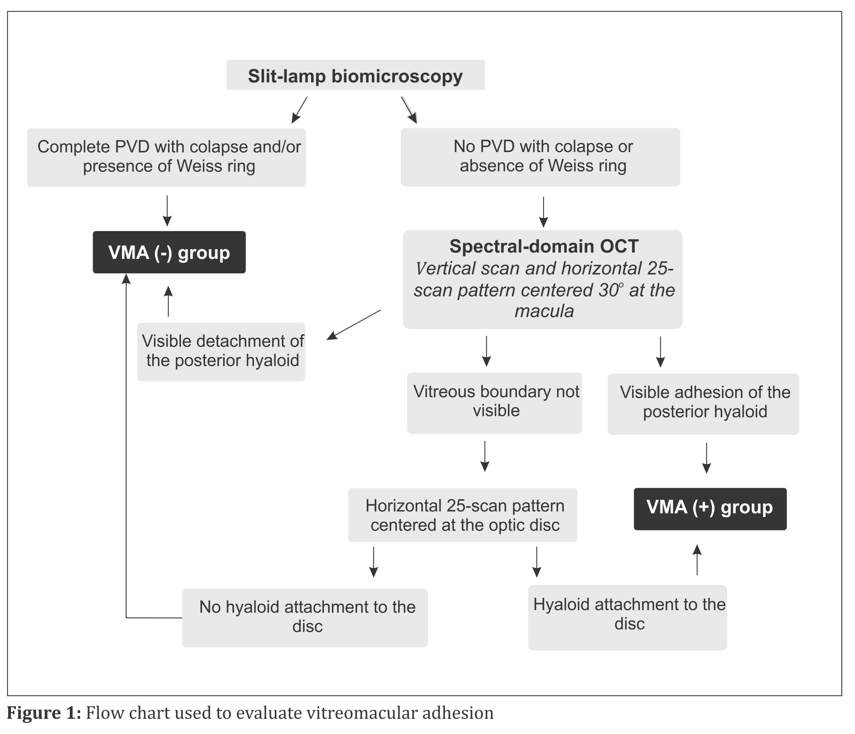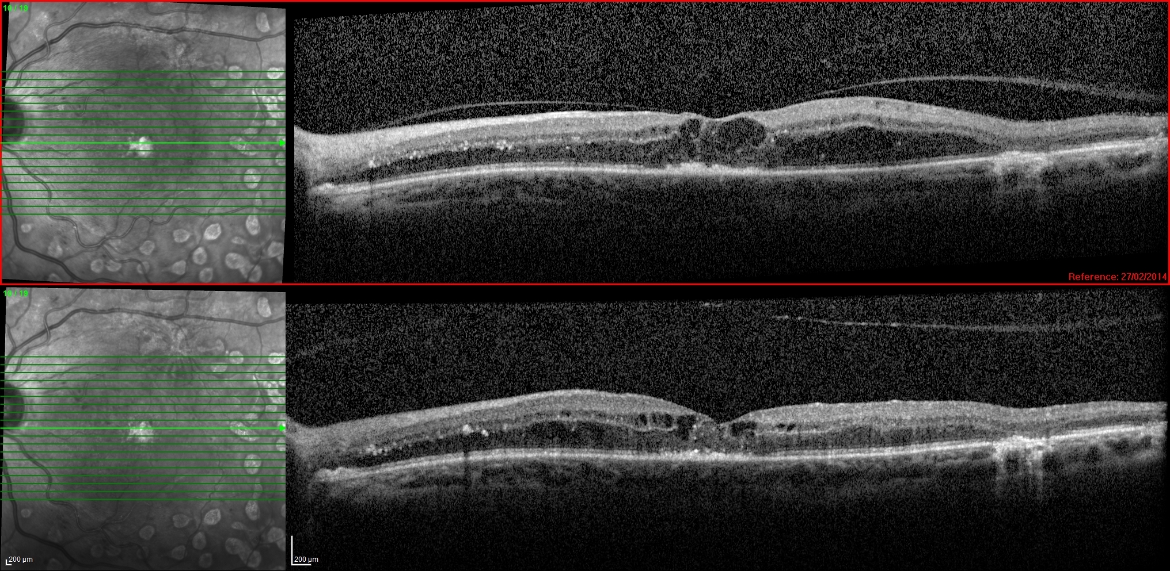

Fig. 2: Example of optical coherence tomography scan showing vitreomacular adhesion (VMA) release and improvement in central retinal thickness following intravitreal anti-VEGF injection. Top: VMA in diabetic macular edema; Bottom: release of VMA 1 month after intravitreal anti-VEGF injection with CRT reduction.

