PROSPECTION OF NEW ANTI-ANGIOGENIC DRUGS BASED ON CHEMICALLY MODIFIED HEPARINS

Vinicius Kniggendorf¹, Juliana L. Dreyfuss², Thatiane Russo², Maria Eduarda Perrud Sousa², Alex Treiger Grupenmacher¹, Caio V. Regatieri^{1,2}

^{1.}Department of Ophthalmology and Visual Sciences, Universidade Federal de São Paulo, Escola Paulista de Medicina, São Paulo, Brazil.

^{2.}Department of Biochemistry, Molecular Biology Division, Universidade Federal de São Paulo, Escola Paulista de Medicina, São Paulo, Brazil.

Corresponding author:

Vinicius Kniggendorf, MD
Federal University of Sao Paulo, Department of Ophthalmology
vinicius_kdorf@yahoo.com.br

*The authors have no financial or conflicting interests to disclose.
Keywords: Macular Degeneration, Angiogenesis Inhibitors, Drug Therapy, Choroidal Neovascularization, Vascular Endothelial Growth Factor A.

Abstract
Purpose: The purpose of this study is to investigate the anti-angiogenic effect of chemically modified heparins (mHep) in vitro and in vivo.

Methods: N-desulfated Re-N-acetylated (N-DRN) was the mHEP used in this study. In vitro assays with endothelial cells were performed after 24 hours of treatment with mHep at 10ng/ml, 100ng/ml and 1000ng/ml or saline. The following tests were performed: cell tube formation, viability, proliferation, migration and adhesion. Choroidal neovascularization (CNV) was induced in rats with laser, followed by intravitreal injection of N-DRN using a microseringe (100 ng/ml, 1000 ng/ml and balanced salt solution). Immunofluorescence analysis was performed with a confocal microscope. The CNV area and perimeter were measured with ImageJ.

Results: Compared to saline, N-DRN demonstrated a statistically significant reduce in cell proliferation, tube formation, migration and adhesion with no changes in cell viability. Mean measures of CNV area were 58.77 x 10⁶ pixels/mm (±13,33 x 10⁶) and 66,64 x 10⁶ pixels/mm (±17,52 x 10⁶) in group 100 and 1000ng/ml, respectively; while in the control group mean area was 70,53 x 10⁶ (± 17,01 x 10⁶). The p-value in the ANOVA analysis was 0.0065. Perimeter analysis also demonstrated statistical difference (p = 0.0235) with the mean measure of 93,55 x 10⁴, 94,23 x 10⁴ and 102 x 10⁴ in the 100ng/mL, 1000ng/mL and control group, respectively.

Conclusions: N-desulfated Re-N-acetylated is a potencial drug to treat ocular angiogenesis.

Introduction

Choroidal neovascularization (CNV) is an important cause of vision loss, especially in those patients with age-related macular degeneration (AMD), which is the leading cause of vision loss in elderly people in industrialized countries.¹
Treatment of CNV is based on anti-vascular endothelial grown factor (anti-VEGF) inhibitors, but all available drugs have treatment burden, tachyphylasis and non-responders with vision loss over time.²⁻⁴ Therefore, the search for new therapies to treat CNV is of fundamental importance.
Heparin is a glycosaminoglycan that interacts with extracellular matrix and is able to bind to different growth factors and could also interfere in inflammation, cell recognition, migration, proliferation and adhesion.⁵ Also, the longer splice isoforms of VEGF-A, the most important cytokine involved in angiogenesis, contains a heparin-binding domain.^{6,7} Previous studies demonstrated that heparin mimetic could modulate the angiogenesis and has important functions as regulator of vessel growth.
Chemically modified heparins are created after process of depolymerization, desulfation and acetylation to keep the antiangiogenic potential and to remove the interference on hemostasis. The purpose of this study is to investigate the anti-angiogenic effect of a chemically modified heparin (mHep), N-desulfated Re-N-acetylated (N-DRN), in vitro and in vivo.

Methods

In vitro

In vitro methods were based on previous studies, and are described bellow.^{5,8,9}

Cell Culture

Adult human retinal pigment epithelial cells (ARPE-19) that were grown in basal DMEM/F12 medium (Invitrogen, San Diego, CA) containing 10% fetal bovine serum (Cultilab, Campinas, Brazil), 15 mM HEPES, 2.0 mM L-glutamine, 0.5 mM sodium pyruvate, and 20 mM sodium bicarbonate, based on previous studies reports. Endothelial cells (EC) were grown in F12 medium (Invitrogen) containing 10% fetal bovine serum (Cultilab) and 20 mM sodium bicarbonate. All cultures were performed on Falcon culture plates (BD Falcon, San Jose, CA).

Capillary-like Tube Formation

Matrigel purified from EHS tumor was thawed at 4⁰C on ice and plated on the bottom of 24 well-plates, and left at 37ºC for 16 hours for gelification. ECs (105 cells) were seeded on Matrigel in F12 medium containing 10% FBS and different amounts of N-DRN (10, 100, 1000 ng/mL) or saline (control). The cultures were maintained at 37ºC in a 2.5% CO2 humidified atmosphere for 24 hours. Taking into consideration that the volume of rat vitreous is approximately 50 μL, the concentrations of the heparinoid used for the cells mimic those used in direct intravitreous injection. Each treatment was performed in triplicate. Tube formation was examined under an inverted light microscope at 100x magnification. Three images were randomly taken in different areas and quantified by two different observers. The total length of connected cells forming tubular structures on the matrigel was measured and determined using image analysis software (Image J, National Institutes of Health, Bethesda, MD, USA). Results are expressed as mm tube length/cm2 area.

Cell Viability Assay

Cytotoxicity was determined using the 3-(4,5-dimethylthiazol-2-yl)-2,5-diphenyltetrazoliumbromide (MTT) assay. For this assay, 105 ARPE-19 cells or 2x10⁴ endothelial cells were seeded in 96-well plates and cultured for 5 days. The medium was removed and fresh medium containing 10% FBS and different amounts of N-DRN (10, 100, 1000 ng/mL in 200 μL/well) or saline (control) added and the cells maintained for 24 hours (37ºC, 5% CO2). Afterwards, the cells were washed with PBS and serum free medium containing MTT (0.5 mg/mL) added. After 2 hours of incubation, isopropanol extraction was performed and the absorbance measured at 540 nm with an ELISA reader (ELx800 BioTek Instruments, Winooski, VT).

Cell Proliferation Assay

Rabit aortic endothelial cells were seeded in a 96-well plates (2x10⁵cells/well) and were cultured in human coagulation factor XII (F12) with 10% FBS in the presence of different concentrations of the N-DRN (10, 100, 1000 ng/mL) or saline (control) and were maintained for 24 hours (37ºC, 2,5%CO2). Analysis was performed by direct counting in the Neubauer chamber after 24 and 48 hours of treatment.

Cell Migration Assay

For this assay, 24-well plates with 10% FBS and Transwell inserts (Corning Life Sciences) were seeded with endotelial cells (5x10⁴cells/well) in the presence of different concentrations of the N-DRN (10, 100, 1000 ng/mL) or saline (control) and were maintained for 16 hours (37ºC, 2,5%CO2). Then, inserts were washed with PBS, fixated with paraformaldehyde, permeabilized with Methanol and stained with 4′,6-diamidino-2-phenylindole (DAPI). Analysis was performed using ImageJ.

Cell Adhesion Assay

Adhesion was determined using 96-well plates with laminin and BSA (control) maintained for 4 hours at 37ºC (2,5%CO2) and overnight at 4 ºC. Non adherent coat was then seed with endothelial cells (3x10⁴cells/well) in the presence of different concentrations of the N-DRN (10, 100, 1000 ng/mL) and were maintained for 3 hours (37ºC, 2,5% CO2) followed by Crystal Violet staining. After addition of sodium citrate, the absorbance measured at 450 nm with an spectrophotometer.

In vivo

Animals

In vivo study was performed in 30 male, heterozygote, pigmented Zucker rats, weighing between 180 and 250g. The animals were kept under natural light-dark cycle, temperature and humidity with food and water ad libitum. All experiments were performed in accordance with Association for Research in Vision and Ophthalmology (ARVO) and Animal Care Ethics Committee of the Federal University of Sao Paulo (number: 5726120717).

Induction of Choroidal Neovascularization

A Laser-induced Choroidal Neovascularization model based on previous studies was used. Animals were anesthetized with intramuscular injection of 56mg/kg of ketamine and 6 mg/kg of xilazine. Application of one drop of 1% tropicamide was used for pupil dilation. The rats were positioned at the slit lamp and a handheld coverslip associated with a drop of 2% methylcellulose was used as a contact lens.
Photocoagulation was performed in the right eye, using argon laser equipment (532nm green wavelength; Quantel Medical, Cournon d’Auvergne, France). Laser protocol was power of 120mW, spot size 100 μm, duration of 100ms and four lesions around optic disc (3, 6, 9 and 12 o’clock) located approximately 2 disc diameters from the optic nerve. The aim was a rupture in Bruch’s membrane indicated by an air bubble at the moment of the application.

Intravitreal Injection

Animals receveid an intravitreal injection (5µl) using a microseringe (Hamilton Co, Reno, NV) immediately after the laser. Rats were assigned to control group (BSS), 100ng/ml N-DRN and 1000ng/ml N-DRN. Animals with traumatic lens injury, vitreous or retinal hemorrhage were excluded from the study.

Immunofluorescence analysis

Two weeks after photocoagulation the animals were euthanized and the eyes enucleated. The eyecups were fixed with 4% paraformaldehyde for 2 hours, washed in 0.1M glycine in Phosphate-Buffered Saline (PBS) and incubated with sucrose 20% overnight. Then, the eyecups were incubated in 0.1% saponin and 2.5% Bovine Serum Albumin (BSA) in PBS followed by overnight incubation with anti-Von Willebrand factor 1:50 (Santa Cruz Biotechnology, Santa Cruz, CA sc-8068). Secondary antibody incubation was performed using Alexa Fluor 488 anti-goat (Molecular Probes, Carlsbad, CA). for 30 minutes and after the eyecups were washed with PBS and flat-mounted to confocal microscope analysis ( Leica SP8, Wetzlar, Germany).
The neovascularization area and perimeter was measured by two different analyzers, using ImageJ Software (National Institutes of Health) in a pixels/mm scale.

Statistical analysis

Data are expressed as means ± standard error of the mean. Statistical analyses were performed using one-way ANOVA with Bonferroni’s post test, using Graph Pad Prism 5.0 software for MAC. A 95% confidence interval and a 5% level of significance were adopted; therefore, the results with P-value less than or equal to 0.05 were considered significant.

Results

In vitro

N-DRN inhibits capillary tube formation

All doses of the N-DRN inhibited capillary tube formation when compared to control (BSS group). The decrease in total mm of tube length was statistically significant (P <0.01) for all doses of the N-DRN (Fig.1).

N-DRN does not affect cell viability.
The results of the cytotoxicity test using the MTT method in endothelial cells treated with different concentrations of chemically modified N-DRN demonstrated a 5% increase in the viability of the ECs comparing the control group with the group treated with 100 ng/mL. There was a reduction of approximately 10% in cell viability (statistically significant difference) comparing the 100 ng/mL group with the 1000 group ng/mL.
The analysis of cytotoxicity in retinal pigment epithelium cells ( ARPE 19) shows a reduction in viability in approximately 10% of ARPEs comparing the control and 10ng/mL groups. Treatment with N-DRN at concentrations of 100 and 1000 ng/mL did not alter the viability of ARPE 19. (Fig. 2)

N-DRN inhibits endothelial cell proliferation
All doses of the N-DRN inhibited endothelial cell proliferation when compared to control (BSS group) in the first 24 hours. Comparing the control with 1000 ng/mL group, there was a significant statistical difference with a reduction approximately 1.36x of cell proliferation. There was no difference between groups in the 48 and 72 hours post cells treatment. (Fig.3)

N-DRN inhibits endothelial cell migration.
Treatment with N-DRN was able to decrease the migration rate of ECs when compared to control. Treatment of ECs with 10 and 100ng/mL group was able to decrease the migration rate by 1.5x when compared to control, while 1000 ng/mL group decreased migration in 2.0x. These results are statistically significant. There was no difference in the migration rate of ECs when the groups are compared to each other. (Fig.4)

N-DRN inhibits endothelial cell adhesion.
The results of cell adhesion assay demonstrated an approximately 6% decrease in the ECs adherence rate in the treatment groups ( 10 ng/mL, 100ng /mL and 100 ng/mL) when compared to the control at a concentration of 20 μg / mL laminin. (Fig.5)

In vivo

Thirty rats were divided into 3 groups (BSS, 100ng/mL and 1000ng/mL). In the BSS group, two rats died during the anesthesia and 28 rats complete the study ( 8 rats in control, 10 rats in 100ng/mL and 10 rats in 1000ng/mL).
The area comparison demonstrated a significant statistical difference between control and treatment groups. Mean measures of membrane area were 58.77 x 10⁶ pixels/mm (±13,33 x 10⁶) and 66,64 x 10⁶ pixels/mm (±17,52 x 10⁶) in group 100 and 1000ng/ml, respectively; while in the control group mean area was 70,53 x 10⁶ (± 17,01 x 10⁶). The p-value in the ANOVA analysis was 0.0065. In the Bonferroni's multiple comparisons test, control x 100ng/mL and control x 1000ng/mL demonstrated a p-value of 0.0067 and 0.0312, respectively. Perimeter analysis also demonstrated statistical difference (p = 0.0235) with the mean measure of 93,55 x 10⁴, 94,23 x 10⁴ and 102 x 10⁴ in the 100ng/mL, 1000ng/mL and control group, respectively. (Fig.6)

Discussion

Angiogenesis is a process of new blood vessels growth from existing vasculature; it begins with endothelial cell activation, degradation of vascular basement membrane and vascular sprouting within interstitial matrix.⁶ Extracellular matrix (ECM) is extremely important since provides signaling for endothelial cell proliferation, survival and migration after binding to integrin; also the dynamic remodeling of ECM by metalloproteinase is related to vascular tube formation.¹⁰
The VEGF-A is the most important component to stimulate angiogenesis and contains a heparin-binding domain (HBD).⁷ The mechanism of activity regulation is complex, since heparin and heparan sulfate could bind to both VEGF and it receptors. The stability of VEGF-A is increased when bound to heparin, with bioavailability and protein half-life control, which leads the HBD to a therapeutic target for diseases related to VEGF.¹¹
N-DRN was able to reduce cell proliferation, tube formation, migration and adhesion with no changes in cell viability. Therefore, N-DRN could modulate the angiogenesis and demonstrated to be safe in vitro.
The application of heparin in vivo needs to interfere only in angiogenesis and inflammation because anticoagulant effect could have consequences like submacular hemorrhage, with irreversible vision loss due to barrier effect, tractional changes (clot contraction) and toxicity (hemosiderin).¹² To control hemostasis effects, heparin was submitted to process of depolymerization, desulfation and acetylation creating the chemically modified heparin (mHEP) called N-desulfated Re-N-acetylated (N-DRN).
The study in rats demonstrated that the area and perimeter measurement was statistically different between control and treatment groups, showing the potencial effect of N-DRN in angiogenesis. This could be attributed to the heparin-binding domain controlling the VEGF-A levels and also the cellular response demonstrated in vitro study.
Previous studies of heparinoid have already suggested the effect in cytokines and growth factors leading to the blockage of the angiogenesis modulation, inhibiting the matrix metalloproteinases and modifying the cell migration and proliferation response⁵, which is in accordance to in vitro and in vivo results of N-DRN.
Therefore, in vitro and in vivo analysis demonstrated that N-desulfated Re-N-acetylated is a potencial drug to treat ocular angiogenesis.

References

1. Congdon N, O'Colmain B, Klaver CC, et al. Causes and prevalence of visual impairment among adults in the United States. Archives of ophthalmology 2004;122:477-85.
2. Binder S. Loss of reactivity in intravitreal anti-VEGF therapy: tachyphylaxis or tolerance? The British journal of ophthalmology 2012;96:1-2.
3. Spooner KL, Mhlanga CT, Hong TH, Broadhead GK, Chang AA. The burden of neovascular age-related macular degeneration: a patient's perspective. Clinical ophthalmology 2018;12:2483-91.
4. Keane PA, de Salvo G, Sim DA, Goverdhan S, Agrawal R, Tufail A. Strategies for improving early detection and diagnosis of neovascular age-related macular degeneration. Clinical ophthalmology 2015;9:353-66.
5. Dreyfuss JL, Regatieri CV, Lima MA, et al. A heparin mimetic isolated from a marine shrimp suppresses neovascularization. Journal of thrombosis and haemostasis : JTH 2010;8:1828-37.
6. Carmeliet P, Jain RK. Molecular mechanisms and clinical applications of angiogenesis. Nature 2011;473:298-307.
7. Zhao W, McCallum SA, Xiao Z, Zhang F, Linhardt RJ. Binding affinities of vascular endothelial growth factor (VEGF) for heparin-derived oligosaccharides. Bioscience reports 2012;32:71-81.
8. Regatieri CV, Dreyfuss JL, Melo GB, Lavinsky D, Farah ME, Nader HB. Dual role of intravitreous infliximab in experimental choroidal neovascularization: effect on the expression of sulfated glycosaminoglycans. Investigative ophthalmology & visual science 2009;50:5487-94.
9. Regatieri CV, Dreyfuss JL, Melo GB, et al. Quantitative evaluation of experimental choroidal neovascularization by confocal scanning laser ophthalmoscopy: fluorescein angiogram parallels heparan sulfate proteoglycan expression. Brazilian journal of medical and biological research = Revista brasileira de pesquisas medicas e biologicas 2010;43:627-33.
10. Senger DR, Davis GE. Angiogenesis. Cold Spring Harbor perspectives in biology 2011;3:a005090.
11. Krilleke D, Ng YS, Shima DT. The heparin-binding domain confers diverse functions of VEGF-A in development and disease: a structure-function study. Biochemical Society transactions 2009;37:1201-6.
12. Novelli FJD, Preti RC, Monteiro MLR, Nobrega MJ, Takahashi WY. A New Method of Subretinal Injection of Tissue Plasminogen Activator and Air in Patients With Submacular Hemorrhage. Retina 2017;37:1607-11.

Figures

Fig.1 Capillary Tube Formation. The graphic demonstrates the analysis of tube formation (percentage of total length of segments). (*p<0,01; **p<0,001; ***p<0,0001).
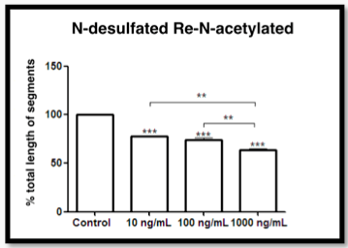

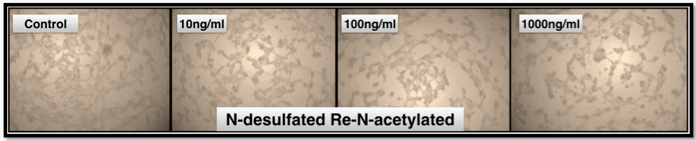

Fig.2 Cell Viability. A) Analysis of retinal pigment epithelium cells (ARPE 19) viability. B) Analysis of endothelial cells viability. Statistically evaluated by ANOVA followed by the Bonferroni test (*p<0,01; **p<0,001; ***p<0,0001).

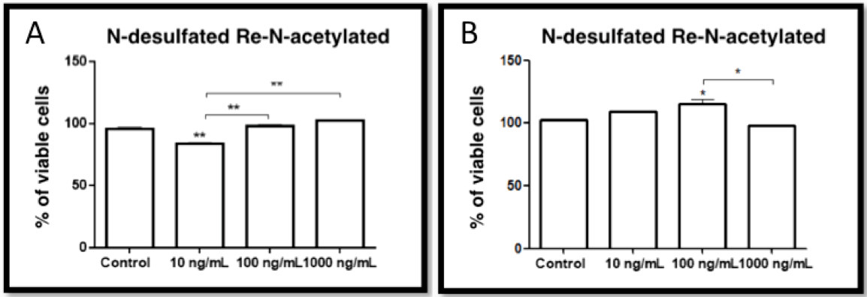

Fig.3 Cell Proliferation. Rabbit aortic endothelial cells exposed to N-DRN (10 ng/ml, 100 ng/ml and 1000 ng/ml) or saline (control) for 24h, 48h or 72h. (* p <0.01; ** p <0.001; *** p <0.0001).

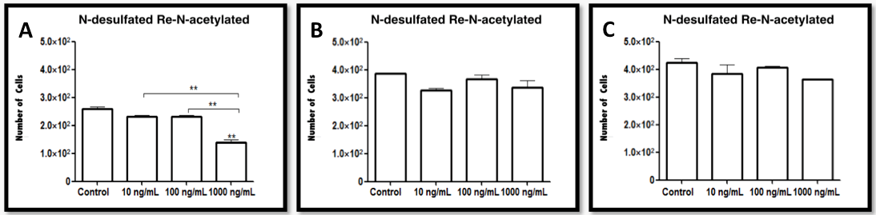

Fig.4 Cell Migration. Migration endothelial cells after treatment with concentrations of N-DRN (10 ng/ml, 100 ng/ml and 1000ng/ml). (* p <0.01; ** p <0.001; *** p <0.0001).
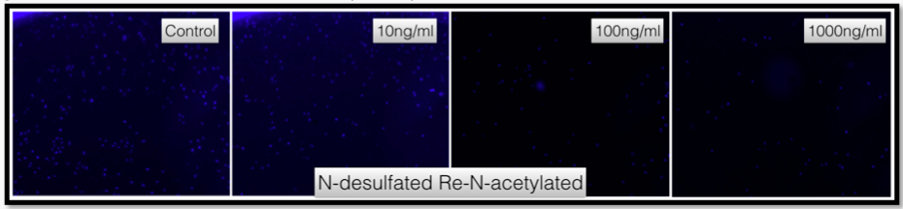
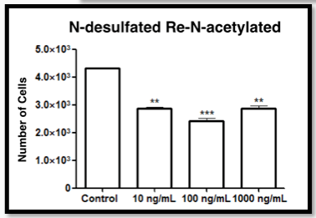

Fig.5 Cell Adhesion. Adhesion of endothelial cells after treatment with concentrations of N-DRN (10 ng/ml, 100 ng/ml and 1000ng/ml). (p <0.05)
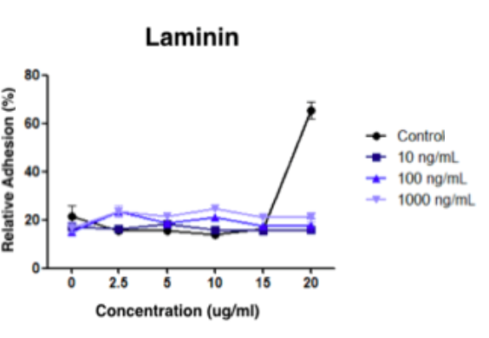

Fig.6 Choroidal Neovascularization. Examples of laser induced choroidal neovascular membrane area measure. A) Control group B) 100ng/mL C) 1000ng/ML.
