Release of Silicone Oil from Syringes and Needles Commonly Used in Ophthalmology

Gustavo B Melo^{1,2}, Natasha F S Cruz², Lydianne L. M. Agra^{1,2}, Christine Probst³ , Luiz H Lima², John Carpenter⁴, Michel E Farah², Maurício Maia²

Author Affiliations: ¹Hospital de Olhos de Sergipe, Aracaju, Brazil; ²Federal University of São Paulo, São Paulo, Brazil; ³Luminex Corporation, Seattle, USA; ⁴University of Colorado, Aurora/Denver, USA

Corresponding Author: Gustavo Barreto de Melo, MD, PhD, Rua Campo do Brito, 995 São José, Aracaju-SE, 49020-380, Brazil (e-mail: gustavobmelo@yahoo.com.br).

Abstract
Background/Aims: Twenty-five million intravitreal injections (IVI) are performed annually worldwide. Silicone oil has been identified in syringes and needles by different techniques. The objective of this study was to quantify the number of oil particles in syringes and in the inner lumen of needles.

Methods: Eight models of syringes (“Unmarketed” oil-free, HSW Normject, HSW Softject, Zero Residual Luer-lock, BD Luer-lok, BD Tuberculin, BD Ultra-Fine, and SR Tuberculin) were analyzed by imaging flow cytometry for the release of silicone oil under agitation by flicking and compared with no agitation. Additionally, eleven models of needles (BD PrecisionGlide 27G and 30G, BD Eclipse 30G, JBP 27G, 30G, 33G, and 34G, TSK 27G, 30G, and 34G, and Zero Residual 30G) were analyzed by imaging flow. Samples were fluorescently labeled using the Amnis Silicone Oil Detection Kit (Luminex Corp, Seattle, WA). All data were collected using an Amnis FlowSight imaging flow cytometer.

Results: One hundred and ninety-two syringes were analyzed. Agitation by flicking caused a statistically significant increase in the number of oil droplets in comparison to no agitation in all syringe groups tested, except for the “Unmarketed” oil-free one. These findings were similar regardless of the drug used. Baseline unagitated groups showed negligible levels of oil (< 40 particles/uL) in all but BD Ultra-Fine (155 particles/uL) and SR Tuberculin (954 particles/uL). Of the 11 needle models evaluated, only one presented a noticeable release of silicone oil – the BD Eclipse 30G. No relationship between needle diameter (gauge) and silicone oil release was observed in any of the studied models.

Conclusion: Silicone oil droplets are released by the syringes. Agitation by flicking prior to injection tends to release more silicone oil. This study showed that most of the commercially available ones that are used in ophthalmic procedures do not release silicone oil from its inner surface and the needle diameter does not influence this finding.

Keywords: intravitreal injection; needle; silicone oil; syringe.

Introduction
The off-label use of syringes in ophthalmology is commonplace. Since anti-vascular endothelial growth factor (VEGF) agents are effective for treating age-related macular degeneration,[1] the number of intravitreal injections and their use has increased dramatically.
The manufacturing process of most commercially available syringes relies on siliconization of the inner surface of the syringe barrel, which facilitates reduced force to initiate the movement of the plunger and its subsequent gliding.[2,3]
Silicone oil (SO) droplets in the vitreous have been identified in clinical studies.[4-7] Bakri and Ekdawi[4] identified 15 eyes with presumed SO droplets after 1,529 injections. Khurana et al.[5] estimated that the incidence rates of presumed SO droplets in the vitreous cavity after intravitreal bevacizumab (Avastin, Genentech Inc., South San Francisco, CA) injections using insulin syringes range from 0.03% (3,230 injections) to 1.7% (3,402 injections) at different time periods. Our group found SO droplets, regardless of their size and clinical impact, in the vitreous of 68% and 75% of 37 consecutive eyes treated with intravitreal injections when assessed by slit-lamp and ultrasound examination, respectively (unpublished data). We also found that the greater the number of previous injections, the higher the likelihood was of having more SO in the vitreous when the ultrasound scans were analyzed using area measurement software.
The presence of SO droplets in the vitreous might become symptomatic, leading to the complaint of floaters, and sometimes require vitrectomy with associated risks.[8]
Considering that syringes are the most likely source of the SO droplets in the eyes of subjects undergoing intravitreal injections,[2] the purpose of the current study was to assess the release of SO from different brands of syringes and needles often used for intravitreal injection.

Materials and methods

Eight models of syringes (“Unmarketed” oil-free, HSW Normject, HSW Softject, Zero Residual Luer-lock, BD Luer-lok, BD Tuberculin, BD Ultra-Fine, and SR Tuberculin) were analyzed by imaging flow cytometry for the release of silicone oil under agitation by flicking and compared with no agitation. Additionally, eleven models of needles (Becton-Dickinson (BD) PrecisionGlide 27G and 30G, BD Eclipse 30G, Japan Bio Products (JBP) 27G, 30G, 33G, and 34G, TSK Co. (TSK) 27G, 30G, and 34G, and Zero Residual 30G) were analyzed by imaging flow. Samples were fluorescently labeled using the Amnis Silicone Oil Detection Kit (Luminex Corp, Seattle, WA). All data were collected using an Amnis FlowSight imaging flow cytometer (Luminex, Seattle, WA) and data were analyzed using IDEAS 6.2 (Luminex, Seattle, WA) image analysis software.

Syringe Preparation
The syringes generally were prefilled with buffer, bevacizumab, ziv-aflibercept and aflibercept to 0.05 mL (backfilled either via their detachable needle or their own pre-attached needle). Air, when stated, also was aspirated up to 0.04 mL to facilitate injection of the entire amount of fluid, which prevents fluid retention in the dead space of the syringe.
After drawing the fluid and air, when indicated, the syringe initially was kept upright in all groups with the needle side facing up. In groups 1, 4, 5, 6, and 7, the syringes were agitated with five consecutive flicks (i.e., sudden release of a bent finger, causing a sharp motion). Subsequently, the syringe was turned 180 degrees so that the needle faced down. The syringes then were flicked 10 consecutive times. One investigator (GBM) performed the previous steps in all syringes to avoid inter-examiner variability.

Needle Preparation
Fifty microliters of buffer were pipetted into the needle hub and then expelled with air with an oil-free syringe (B. Braun Injekt) attached to the needle in order to avoid contamination with the known silicone oil present on the outer surface of the needle.

Analysis by imaging flow cytometry
Samples were fluorescently labeled using the Amnis Protein Aggregate and Silicone Oil Detection Kit (Luminex Corp, Seattle, WA). The Amnis Kit contains BODIPY at a stock concentration of 1.5 mM (“1000X”) in dimethyl sulfoxide, ProteoStat at a stock concentration of 0.75 mM (“1000X”) in dimethyl sulfoxide, as well as aggregated IgG as a positive control and monomeric IgG as a negative control.
All data were collected using an Amnis FlowSight imaging flow cytometer (Luminex, Seattle, WA) and data were analyzed using IDEAS 6.2 (Luminex, Seattle, WA) image analysis software. Calcium-free, magnesium-free phosphate-buffered saline (PBS) was purchased from Invitrogen (Carlsbad, CA) and used as IFC sheath fluid.

Selection of Fluorescence Labels for Protein Aggregates and Silicone Oil Droplets
This study aimed to differentiate protein and silicone particles
using 2 extrinsic fluorescence dyes that have selective affinity for either material type, bind noncovalently, require no purification step such as centrifugation or filtration, and emit at different wavelengths that can be resolved in separate IFC channels. ProteoStat was selected as the protein aggregate label. BODIPY 493/503 is a lipophilic dye (peak excitation of 480 nm and peak emission of 515 nm) that was selected as the silicone oil label. As “mix- and-read” dyes, ProteoStat and BODIPY require no conjugation or purification and are both excited by the 488 nm laser which comes standard with all IFC instrumentation, achieving the desired characteristics outlined previously.

FlowSight IFC Data Acquisition
IFC experiments were conducted using a 20X magnification objective in high-sensitivity mode (flow rate: 1.14 mL/min), which generates images with 1 mm pixel resolution and a 60 mm wide field-of-view. The 785 nm SSC excitation laser was set to 10 mW and the 488 nm fluorescence excitation laser was set to 60 mW. BF was set to channels 1 (457/45 nm) and 9 (582/25) and intensity is set automatically by the instrument software to achieve consistent background; SSC images were collected in channel 6 (emission 762/ 35); BODIPY images were collected in channel 2 (528/65); ProteoStat images were collected in channel 4 (610/30); BODIPY precipitates were detected using channel 5 images (702/85). All events detected were collected (i.e., no user threshold applied). Each sample was measured until 20,000 events had been collected for up to 5 min time (for diluted samples).

Statistical Analysis
Statistical analyses were performed using SPSS 20.0 (IBM Corp., Version 20.0, Armonk, NY) and STATA 12 (StataCorp2011, College Station, TX) software. The mean numbers of SO droplets and standard deviations also are reported. The mean numbers of SO droplets among the groups and syringes were assessed using the Kruskal-Wallis non-parametric test. The Dunn-Bonferroni’s post hoc test was performed on each pair of groups. To compare the number of SO droplets in the same syringe, the Wilcoxon test was applied, and a multiple linear regression model was used to adjust for the negative values in this comparison. P = 0.05 was considered statistically significant.

Results

A total of 192 syringes (24 per model; 3 for each condition and drug) and 33 needles (3 per model) were assessed.
Following optimization of dye labeling conditions, the capability of IFC to identify silicone oil droplets, protein aggregates, and protein-silicone oil interactions using fluorescent labeling was evaluated. Figure 1 shows bivariate plots of BODIPY (Ch02) versus ProteoStat (Ch04) fluorescence intensity measured using IFC for samples containing aggregated protein alone, a 50:50 mixture of aggregated protein and silicone oil emulsion, and the same 50:50 mixture with addition of a surfactant (0.1% Triton X-100).
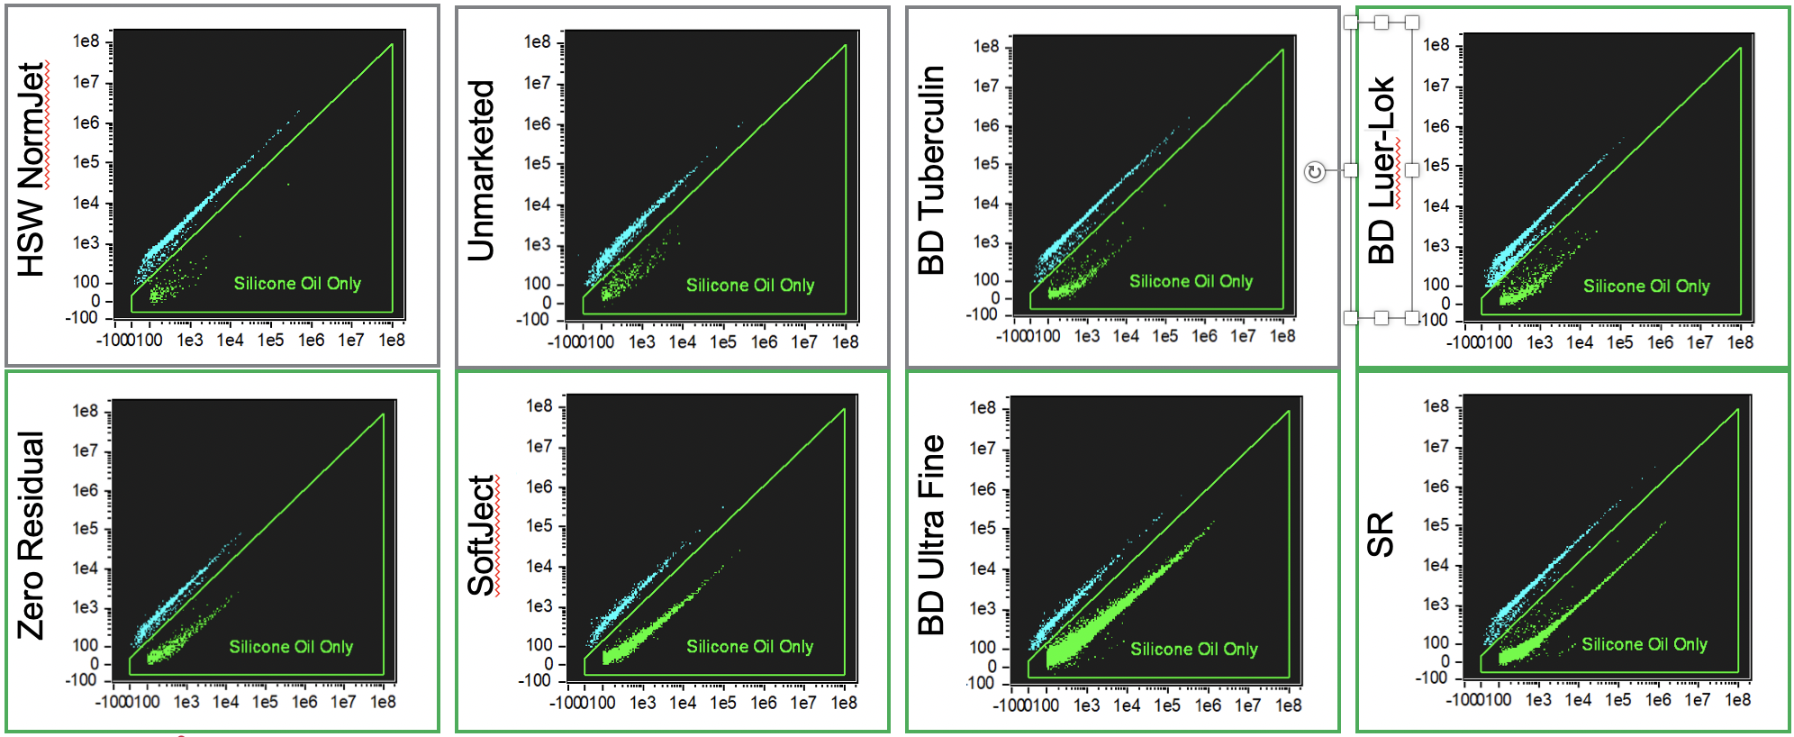
Figure 1: Measurement of protein aggregates, silicone oil droplets, and interactions using BODIPY (Ch02) versus ProteoStat (Ch04) intensity bivariate for HSW Norm-Ject, Unmarketed, BD Tuberculin, BD Luer-lok, Zero Residual, Soft-Ject, BD Ultra-Fine, and SR. Particles were classified using gates applied to the bivariate intensity plots: “Protein Aggregate” (blue), “Silicone Oil” (green).
Data were collected for labeled water and silicone oil emulsion as “particle-free” and “silicone oil-only” controls. As expected, few particles were detected in the labeled water sample, indicating that the fluorescence labeling itself does not introduce a significant number of fluorescent precipitates.
Taking into account the syringe comparison, the following results were found: agitation by flicking caused a statistically significant increase in the number of oil droplets in comparison to no agitation (Figure 2). The total oil particle count per microliter of the unagitated samples were as follows: Zero Residual Luer-lock (14 particles/μL), “Unmarketed” SO-free (32 particles/μL), BD Luer-lok (32 particles/μL), BD Tuberculin (32 particles/μL), HSW Norm-Ject (36 particles/μL), HSW Soft-Ject (38 particles/μL), BD Ultra-Fine (155 particles/μL), and SR Tuberculin (954 particles/μL). When agitated by flicking, the number of oil particles disclosed a statistically significant increase in all syringes in comparison to the no-agitation state, except for the “Unmarketed” oil-free one. After agitation, the number of particles detected were as follows: Zero Residual Luer-lock (431 particles/μL), “Unmarketed” SO-free (68 particles/μL), BD Luer-lok (234 particles/μL), BD Tuberculin (258 particles/μL), HSW Norm-Ject (80 particles/μL), HSW Soft-Ject (711 particles/μL), BD Ultra-Fine (3,703 particles/μL), and SR Tuberculin (2,918 particles/μL). These findings represent the average of all drugs together (buffer, bevacizumab, ziv-aflibercept and aflibercept) and were similar regardless of the drug used.

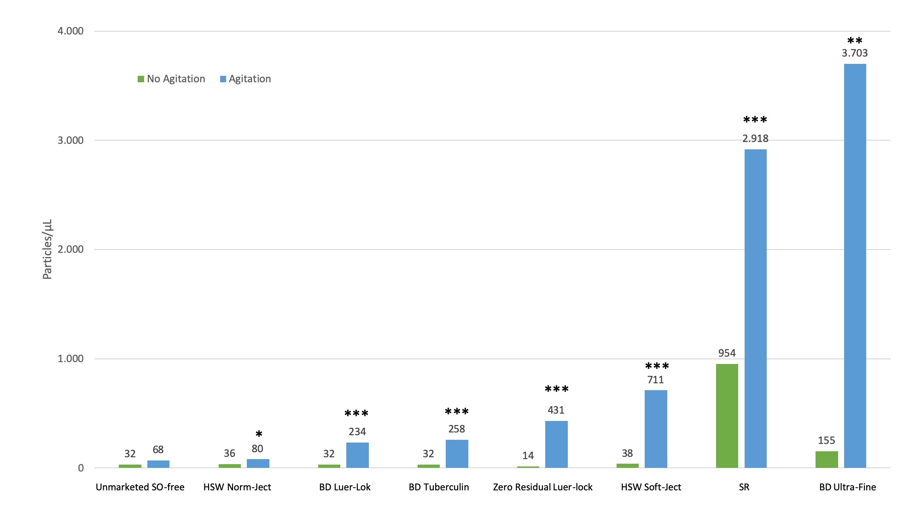
Figure 2: Graph shows the number of silicone oil particles per microliter from different syringes without and with agitation by flicking. Silicone oil was labeled with a fluorescent dye and assessed by imaging flow cytometry. Syringes without agitation (green bar) and after agitation (blue bar) are represented. *p<0.05; **p<0.01; ***p<0.001.

Of the 11 needle models evaluated, only one presented a noticeable release of silicone oil – the BD Eclipse 30G. No relationship between needle diameter (gauge) and silicone oil release was observed in any of the studied models (Figure 3).

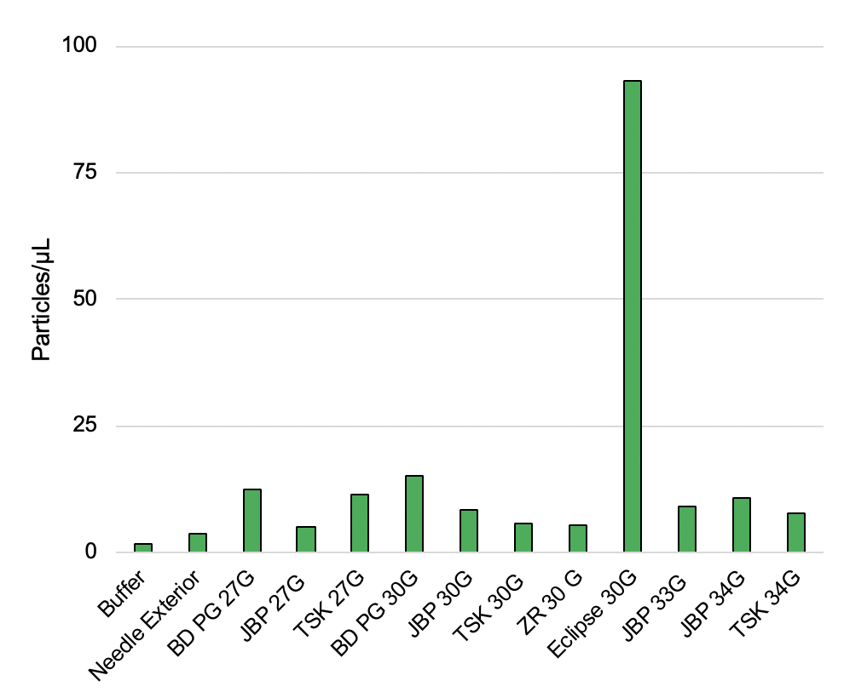
Figure 3: Graph shows the number of silicone oil particles per microliter from different needles, including the analysis of buffer only and the outer surface of needle (needle exterior), as controls. Silicone oil was labeled with a fluorescent dye and assessed by imaging flow cytometry.

Discussion
It should be remarked that the syringes were chosen for the current analysis because anecdotal information led the authors to believe they comprised some of the most commonly used models in some European countries and in North America. BD Tuberculin, BD Ultra-Fine and HSW Norm-Ject are often sold with bevacizumab by compounding pharmacies in the USA. BD Luer-Lok is distributed in the same package as aflibercept both in Europe and in the USA. Both the BD Ultra-Fine, although USA-made, is largely found and used in Brazil as well. The SR syringe is largely available in Brazil, while the Zero Residual Luer-lock is available in Europe.
Case series have reported the presence of persistent droplets in the vitreous of subjects after intravitreal injections and postulated the droplets to be SO lubricant from the syringe used in the procedure.[4-7] This current study identified SO in and released by various syringes used for intravitreal injections and highlighted the impact of agitation by flicking on SO release.
Our previous study also showed similar results when two syringes produced in Brazil (SR, Manaus, Brazil; and BD Plastipak, Curitiba, Brazil) and one US-manufactured syringe (BD SafetyGlide, Holdrege, NE) were tested. Both the SR and BD SafetyGlide syringes had an incremental effect on the release of SO when agitated by flicking. Only the BD Plastipak syringe did not release oil. [11]
We identified SO droplets in some samples from oil-free syringes. We reasoned that the BD PrecisionGlide needle (used for the entire study, except for those syringes with staked-in needles) was the potential source of SO. We previously submitted theBD PrecisionGlide needle to Fourier-transform infrared spectroscopy, which showed an average of 20 μg of SO in each sample. This is a small amount relative to the siliconized syringes in this study but sufficient to explain the positive samples for our oil-free syringes.[12] An additional potential explanation is that, although SO-free, these syringes might have different lubricants that might be stained similarly to SO.
Although SO droplets in the vitreous are often harmless, when the increasing number of intravitreal injections is considered, the number of subjects with clinically relevant SO droplets also may increase. Further complications are possible when vitrectomy is needed to remove the SO droplets.
In addition, retina specialists worldwide are concerned about inflammation after intravitreal injections of antiangiogenics without a clear etiology. Noninfectious vitritis has been reported in 0.10% after 66,356 bevacizumab injections, 0.02% after 26,161 ranibizumab (Lucentis, Genentech Inc.) injections, and 0.16% after 8,071 aflibercept injections (Eylea, Regeneron Pharmaceuticals, Tarrytown, NY).[13] The American Society of Retina Specialists Therapeutic Surveillance Committee also reported notifications of cases of aflibercept-related sterile inflammation. However, the authors did not suggest an explanation.[14] More recently, our group identified six cases of inflammation after aflibercept injections with a new syringe in use at the clinical practice.[15] The syringe was the SR, which also has been shown to release SO with or without agitation. Since one author flicked this syringe to dissociate the fluid from the air and other retina specialists at the same setting did not and had no cases of inflammation, it was speculated that release of SO droplets may contribute to the inflammatory reaction. In agreement with this hypothesis, some studies have reported more intense protein aggregation and insoluble molecules resulting from agitation in the presence of the SO from the syringes.[16-18] Finally, SO droplets also have been reported to act as immunologic adjuvants in dermatologic procedures in the subcutaneous space in mice.[19,20] We believe the risks of SO droplets introduced into the eye or other areas of the body are relevant to ophthalmologists and clinicians in other medical fields.
Discrimination of protein aggregates and silicone oil droplets is routinely performed in analysis of protein therapeutics to evaluate formulation safety and stability; however, classification of particles smaller than 5 mm and measurement of protein-SO interactions remains challenging with current analytical techniques. In this study, a fluorescent labeling protocol was developed to identify protein aggregates and silicone oil droplets with low concentrations of extrinsic fluorescent dyes that interact non-covalently with particles.
Fluorescence-labeling and detection approaches are increasingly emerging as powerful tools for detecting and characterizing particles type and conformation within protein formulations. For example, protein-folding and aggregation state has been evaluated using differential scanning fluorimetry using ProteoStat as the protein label with a polymerase chain reaction instrument as the fluorescent reader;[21] protein aggregates 1-1000 mm within a 96-well plate were rapidly quantified via labeling with Bis-ANS and measured using automated fluorescence microscopy imaging;[22] protein aggregates and silicone oil droplets 10-100 nm were differentiated using SYPROTM Red and SYPROTM Orange labeling combined with raster image correlation spectroscopy;[23] flow cytometry has been used to measure SYPRO Orange labeled protein aggregates[24] and differentiate Alexa FluorTM 647-conjugated protein aggregates and silicone oil droplets prelabeled with BODIPY. [23]
In conclusion, syringes commonly used for intravitreal injections frequently release SO droplets, especially when agitated by flicking. To avoid unnecessary ocular risks, we recommend that the syringes not be agitated at the time of intravitreal injection. In addition, since their use in ophthalmology is off-label, syringes for specific ophthalmic use should be manufactured.

References
- Grzybowski A, Told R, Sacu S, et al. 2018 Update on Intravitreal Injections: Euretina Expert Consensus Recommendations. Ophthalmologica 2018;239:181-93.
- Funke S, Matilainen J, Nalenz H, et al. Analysis of thin baked-on silicone layers by FTIR and 3D-Laser Scanning Microscopy. Eur J Pharm Biopharm 2015;96:304-13. doi: 10.1016/j.ejpb.2015.08.009.
- Sacha GA, Saffell-Clemmer W, Abram K, et al. Practical fundamentals of glass, rubber, and plastic sterile packaging systems. Pharm Dev Technol 2010;15:6-34. doi: 10.3109/10837450903511178.
- Bakri SJ, Ekdawi NS. Intravitreal silicone oil droplets after intravitreal drug injections. Retina 2008;28:996-1001.
- Khurana RN, Chang LK, Porco TC. Incidence of presumed silicone oil droplets in the vitreous cavity after intravitreal bevacizumab injection with insulin syringes. JAMA Ophthalmol 2017;135:800-3.
- Yu JH, Gallemore E, Kim JK, et al. Silicone oil droplets following intravitreal bevacizumab injections. Am J Ophthalmol Case Rep 2017;10:142-4.
- Avery RL, Castellarin AA, Dhoot DS, et al. Large silicone droplets after intravitreal bevacizumab (Avastin). Retin Cases Brief Rep 2017 Mar 15. doi: 10.1097/ICB.0000000000000570.
- Thompson JT. Advantages and limitations of small gauge vitrectomy. Surv Ophthalmol 2011;56:162-72.
- Chamerski K, Lesniak M, Sitarz M, et al. An investigation of the effect of silicone oil on polymer intraocular lenses by means of PALS, FT-IR and Raman spectroscopies. Spectrochim Acta A Mol Biomol Spectrosc 2016;167:96-100. doi: 10.1016/j.saa.2016.05.036.
- Fahmy K, Jäger F, Beck M, et al. Protonation states of membrane-embedded carboxylic acid groups in rhodopsin and metarhodopsin II: a Fourier-transform infrared spectroscopy study of site-directed mutants. Proc Natl Acad Sci USA 1993;90:10206-10.
- Melo GB, Dias Jr CS, Carvalho MR, et al. Release of silicone oil from syringes. Int J Retina Vitreous 2019;5:1.
- Melo GB, Emerson GG, Lima Filho AAS, et al. Needles as a source of silicone oil during intravitreal injection. Eye 2019 Feb 13. https://doi.org/10.1038/s41433-019-0365-7
- Williams PD, Chong D, Fuller T, et al. Noninfectious vitritis after intravitreal injection of anti-VEGF agents. Variations in rates and presentation by medication. Retina 2016;36:909-13.
- Hahn P, Kim JE, Stinnett S, et al., American Society of Retina Specialists Therapeutic Surveillance Committee. Aflibercept-related sterile inflammation. Ophthalmology. 2013;120:1100-101.e1-5. doi: 10.1016/j.ophtha.2012.11.018.
- Melo GB, Figueira ACM, Batista FAH, et al. Inflammatory reaction after aflibercept intravitreal injections associated with silicone oil droplets released from syringes: a case-control study. Ophthalmic Surg Lasers Imaging Retina 2019 (in press).
- Krayukhina E, Tsumoto K, Uchiyama S, et al. Effects of syringe material and silicone oil lubrication on the stability of pharmaceutical proteins. J Pharm Sci 2015;104:527-35.
- Gerhardt A, McGraw NR, Schwartz DK, et al. Protein aggregation and particle formation in prefilled glass syringes. J Pharm Sci 2014;103:1601-12.
- Teska BM, Brake JM, Tronto GS, et al. Aggregation and particle formation of therapeutic proteins in contact with a novel fluoropolymer surface versus siliconized surfaces: effects of agitation in vials and in prefilled syringes. J Pharm Sci 2016;105:2053-65.
- Chisholm CF, Nguyen BH, Soucie KR, et al. In vivo analysis of the potency of silicone oil microdroplets as immunological adjuvants in protein formulations. J Pharm Sci 2015;104:3681-90.
- Wambier CG, Danilau Ostroski TK, Perillo de Farias Wambier S, et al. Syringe lubricant and adverse reactions. Int J Dermatol 2018;57:122-3. doi: 10.1111/ijd.13825.
- McClure SM, Ahl PL, Blue JT. High throughput differential scanning fluorimetry (DSF) formulation screening with complementary dyes to assess protein unfolding and aggregation in presence of surfactants. Pharm Res. 2018;35:81.
- Mach H, Bhambhani A, Meyer BK, et al. The use of flow cytometry for the detection of subvisible particles in therapeutic protein formulations. J Pharm Sci. 2011;100:1671-1678.
- Ludwig DB, Trotter JT, Gabrielson JP, Carpenter JF, Randolph TW. Flow cytometry: a promising technique for the study of silicone oil-induced particulate formation in protein formulations. Anal Biochem. 2011;410: 191-199.
- Shah M, Rattray Z, Day K, et al. Evaluation of aggregate and silicone-oil counts in pre-filled siliconized syringes: an orthogonal study characterizing the entire subvisible size range. Int J Pharm. 2017;519:58-66.

