**Intravitreal bevacizumab (IVB) *versus* IVB in combination with pars plana vitrectomy for vitreous hemorrhage secondary to proliferative diabetic retinopathy: a randomized clinical trial**

Danilo Moyses Jorge1, José Edísio da Silva Tavares Neto1, Omero Poli Neto2, Ingrid U Scott3,Rodrigo Jorge.1

1Department of Ophthalmology, Ribeirão Preto Medical School, University of São Paulo, Brazil

2Department of Gynecology and Obstetrics, Ribeirão Preto Medical School, University of São Paulo, Brazil

3Departments of Ophthalmology and Public Health Sciences, Penn State College of Medicine, Hershey, Pennsylvania, USA

**\*Corresponding author:**

Rodrigo Jorge

retinausp@gmail.com

Address: 3900, Bandeirantes av., Campus, 12fl. Ribeirão Preto city, São Paulo state,

zip 14048-900. Brazil. Phone: +55 (16) 3602-2523

**Registration number:** XXXXXXX

**INTRODUCTION**

Diabetes mellitus (DM) is a chronic multisystemic disease of growing importance to public health. In Brazil, DM is estimated to affect 7.6% of the urban population aged 30-69 years. The more common injuries to target organs are nephropathy, neuropathy and retinopathy, with ocular lesions being present in 29 to 40% of cases. (1) Diabetic retinopathy (DR) is the main cause of blindness among people of productive age in developed countries. After 15 years of the disease, 80% of patients with type 2 DM and 97% of those with type 1 DM are estimated to have some degree of ocular involvement (1) and, without treatment, 50% of the persons with the proliferative form of the disease will be blind within 5 years. (2)

The physiopathology starts with the persistent hyperglycemia that commonly affects diabetic patients, inducing retinal hypoxia and triggering the production of vasoactive factors that may lead to macular edema and/or angiogenesis, with the presence of retinal neovessels representing an important risk factor for loss of vision in patients with DR. (3,4)

Proliferative diabetic retinopathy (PDR) is an important cause of severe visual loss in patients with DM.(3) Laser panretinal photocoagulation (PRP) is the standard treatment for retina’s and optic disc’s neovascularization and approximately 60% of the patients respond to the procedure, with regression of neovascularization (NV) within 3 months.(5) However, in some cases complete NV regression does not occur after PRP and 4.5% of the patients require pars plana vitrectomy despite PRP.

Vascular endothelial growth factor (VEGF) plays an important role in the microvascular complications of the retina (6-8), with its levels being approximately three times higher in patients with PDR compared to nondiabetics individuals and triggering the process of neovascularization (9,10). High VEGF levels inducing neovessels are also observed in other retinal vasculopathies that lead to ischemia, such as occlusion of the central retinal vein and of its central branch. Abnormal and incompetent blood vessels may grow along the posterior surface of the vitreous, causing bleeding inside the vitreous cavity (vitreous hemorrhage) and/or fibrovascular proliferation culminating with traction retinal detachment. (11)

Vitreous hemorrhage (VH) may be traumatic or spontaneous, being linked to PDR in 32% of the latter cases. (12). The standard exam for VH evaluation is A and B mode ocular echography. (13) According to the 1985 Diabetic Retinopathy Vitrectomy Study (DRVS), VH does not disappear spontaneously in 80% of the patients and requires surgery, with pars plana vitrectomy (PPV) being the procedure of choice. However, re-bleeding is observed in 20-40% of patients even after surgery. (11)

The DRVS demonstrated that the time recommended for the execution of vitrectomy is usually 3 months for type 1 diabetics and 6 months for type 2 diabetics. However, depending on clinical indication, the procedure can be performed after waiting 1 month for vitreous reabsorption. (12)

The regression of optic disc’s NV was demonstrated after intravitreous injection of the antiangiogenic agent bevacizumab (Avastin®; Genentech, Inc.; South San Francisco, CA, USA) within the context of DR (14,15). However, this effect seems to be transitory since neovessels tended to recur 12 weeks after a single intravitreous injection of bevacizumab. (16)

The administration of anti-VEGF agents has shown promising results regarding dense vitreous hemorrhage, lowering or stopping the additional leakage of blood to the vitreous cavity and favoring regression of neovascularization with concomitant hemorrhage reabsorption. On this basis, anti-VEGF agents reduce the time required for vitreous clearance, reducing the need for PPV by about 30% (17).

For patients with PDR submitted to vitrectomy, several studies have shown the importance of the application of an anti-VEGF agent within up to 7 days before the surgical procedure in order to avoid intra and postoperative bleeding. (18,19)

In view of the above considerations, the objective of the present study was to analyze the importance of the difference in the improvement of the degree of vitreous hemorrhage between a group treated only with antiangiogenic agent and a group submitted to pars plana vitrectomy, and also to determine the rates of re-bleeding.

1. **MATERIALS AND METHODS**

The study was conducted according to the Declaration of Helsinki after approval by the Local Human Research Ethics Committee and was carried out from January 2019 to December 2019.

**Inclusion and Exclusion Criteria**

Inclusion criteria were: patients older than 18 years, VH duration of more than 1 month, and visual acuity worse than 20/40 in the eye under study. These characteristics were confirmed by indirect ophthalmoscopy and/or ocular echography. All selected subjects gave written informed consent to participate in the study.

Exclusion criteria were: intraocular surgery during the last 3 months, previous posterior vitrectomy, acute ocular infection, any condition that would affect documentation or follow-up, associated traction retinal detachment, clinically uncontrolled glaucoma, severe recent ocular trauma, use of anticoagulant medications (except aspirin), glycosylated hemoglobin of more than 13%, and participation in another clinical study within the last 30 days.

During the recruitment phase, 73 eyes of 66 patients who fulfilled the study criteria were assigned to the study. The ophthalmological exam conducted during the initial evaluation of both groups consisted of best corrected visual acuity recorded with a LogMAR table according to the standardized recommendations of the Early Treatment Diabetic Retinopathy Study (ETDRS) (20), with the exception that hand movements and counting fingers were also employed as visual acuity measurements, when the patient could read chart letters at 1 meter. Applanation tonometry with a Goldmann tonometer, retinal mapping, retinography, and mode B echography in the eye with VH. On the occasion of subsequent follow-up exams, the patients were submitted to the same ophthalmological examination except for ocular B echography. The examiner who checked BCVA and graded the VH score at visits 8, 16 and 24 was masked and was unaware of the group to which each patient belonged.

**Randomization and Treatment Group**

Patients were selected at random by the investigator by drawing lots during the inclusion process. Two patient groups were formed: Group A, in which the patients received a total of 3 intravitreous injections of 0.06 ml (1.5 mg) bevacizumab (Avastin®) administered at 8 week intervals; and Group B in which the patients were submitted to pars plana vitrectomy plus an injection of 0.06 ml bevacizumab (1.5 mg) 7 days before the surgical procedure. The patients received PRP as vitreous clearing permitted the procedure. In the vitrectomy group, endolaser panphotocoagulation was performed in patients who had not yet received complete PRP.

**Intravitreous Injection**

Bevacizumab was administered in a surgical environment at the dose of 1.5 mg (0.06 ml), with a disposable BD Ultra-FineTM 29G ½ syringe, via pars plana, under topical anesthesia, at 3 mm from the limbus in pseudophakic patients and at 3.5 mm from the limbus in phakic patients. After the procedure, perfusion of the optic nerve was assessed by indirect ophthalmoscopy, with paracentesis of the anterior chamber being considered in cases of poor perfusion. The patients were instructed to use antibiotic eyedrops (0.5% moxifloxacin), one drop every 6 hours in the eye to be submitted to the procedure, starting three days before the injection for prophylaxis and continuing for one week after injection in group A patients. Groups B patients were instructed to follow the eyedrop regimen standardized for posterior vitrectomy surgery, i.e., combined eyedrops (moxifloxacin and dexamethasone) for 1 month.

**Standardization of Vitreous Hemorrhage Grades and other outcomes measures**

In the present study, vitreous hemorrhage classified according to the Diabetic Retinopathy Vitrectomy Study (DRVS) (22): grade 1 when details of the retina were visualized with the aid of an binocular indirect ophthalmoscope (BIO), grade 2 in the presence of a red reflex but with retinal details impossible to visualize, and grade 3 in the presence of vitreous hemorrhages with the absence of a red reflex upon IBO examination. Patients with grade 3 vitreous hemorrhage were submitted to ocular ultrasound for the detection of eventual traction retinal detachment. Change in Vitreous hemorrhage score was the primary outcome measure and change in BCVA was used as a secondary outcome measure.

**Pars Plana Vitrectomy**

According to the preoperative routine, exams and the assessment of surgical cardiology risk were requested for all patients on the occasion of the initial evaluation. The type of anesthesia used was left to the discretion of the anesthesia service considering the standards normally used for ophthalmologic surgeries of the posterior segment, with peribulbar blockade with 6 ml 1% ropivacain being usually employed. The surgical technique programmed consisted of phacoemulsification with the implant of an intraocular lens (if the patient was phakic) and posterior pars plana 23 G vitrectomy, partial fluid-air exchange and endolaser panphotocoagulation if the patient had not yet been submitted to complete laser.

**Ophthalmologic Evaluation**

Group A was submitted to ophthalmologic examination on the occasion of the first evaluation and to ocular echography in the eye with VH, and then scheduled for intravitreous injection of 0.06 ml (1.50 mg) bevacizumab. The patients were followed up at 1, 3, 8, 16 and 24 weeks after the procedure, with new bevacizumab injections being applied at 8 and 16 weeks, for a total of 3 applications.

Group B was submitted to an ophthalmological exam at the initial evaluation and to B echography of the eye with grade 2 or 3 VH. The patients were monitored by ophthalmologic examination at 1, 3, 8, 16 and 24 weeks after surgery.

Group A and B patients were reevaluated 24 hours, 1 week and 3 weeks after the procedure in order to determine possible infectious complications, an increase in intraocular pressure or retinal detachment. Vitreous hemorrhage scores were not checked.

**Statistical Analysis**

We used SAS (version 9.3) for statistical analysis. Quantitative variables with skewed distribution were analyzed using the Mann-Whitney test. A mixed effects linear regression model was applied to determine the effect of time on the outcomes. Each time point and each group were compared by orthogonal contrast analysis.

**Sample size estimation**

After a Medline search, there were no studies that presented statistics with means and standard deviations or medians and ranges or confidence intervals for vitreous hemorrhages scores. For this reason, an exploratory analysis was conducted with a small sample size to test this parameter.

1. **RESULTS**

Eighty-eight eyes (81 patients) were invited to the study for having VH causing loss of visual acuity. Five of them were excluded because VH was not related to proliferative diabetic retinopathy. Among the other causes of VH were wet age related macular degeneration (AMD), trauma and vascular occlusions. When submitted to the ocular ecography exam to analyze presence of tractional retina detachment (TRD), 10 eyes/patients were excluded for having VH and TRD. Seventy-three eyes of 66 patients older than 18 years with vitreous hemorrhage secondary to PDR were randomized to both study groups. Group A had 38 eyes and group B 35 eyes. Three patients from group A lost 2 consecutive visits and were excluded. One patient from group A had TRD after his first anti-VEGF injection. Despite this complication, his data was included in the final analysis. At visit 24, 35 eyes from each group were included in the analysis. Seven patients have both eyes included in the study, one in each group. The demographic characteristics of the patients are listed in Table 1, with no significant difference in age, sex or presence of systemic arterial hypertension between groups. Alongside the demographic aspects, Table 1 lists the VH score at baseline, with no significant difference between groups (p>0.05).



**Vitreous Hemorrhage scores**

The distribution of the degrees of vitreous hemorrhage for groups A and B is presented in **Tables 1 to 3**. At baseline, the median score of vitreous hemorrhage was 3 (mean: 2.416) and 3 (mean: 2.578) for groups A and B, respectively (p<0,001).

Mean Vitreous hemorrhage score reduction (± SEM) of 0.4571 **±** 0.1409 (p = 0.0014), 1.3429 **±** 0.1409 (p <0.0001) and 1.8286 **±** 0.1409 (p <0.001) was observed in group A at 8, 16 and 24 weeks after treatment, respectively. (**Table 2, Figure 1**) In Group B, the reduction of VH score (± SEM) was 2.2571 **±** 0.1409 (p = 0.0014), 2.2857 **±** 0.1409 (p <0.0001) and 2.2286 **±** 0.1409 (p <0.001) at 8,16 and 24 weeks after treatment, respectively. Group comparison revealed a significantly greater reduction in mean vitreous score in group B 8 and 16 weeks after treatment (p<0.0001). However, after 24 weeks this difference was no longer statistically significant (p=0.1854). (**Table 3, Figure 1**)

**Best Corrected Visual Acuity (BCVA)**

Mean BCVA was significantly higher at baseline in group A when compared to Group B: there was a difference of 0.3093 ± 0.1237 (p=0.013) in baseline visual acuity between groups. In Group A, mean best corrected visual acuity (± SEM) showed an improvement of 0.00285 **±** 0.0958 (p = 0.971), 0.5371 **±** 0.0958 (p <0.0001), 0.8143 **±** 0.0958 (p <0.0001) and 0.8543 **±** 0.0958 (p <0.0001) compared to baseline at 1, 8, 16 and 24 weeks after treatment, respectively. In group B, mean best corrected visual acuity (± SEM) showed an improvement of 0.3657 **±** 0.0958 (p=0.0002), 0.8857 **±** 0.0958 (p<0.0001), 0.9457 **±** 0.0958 (p<0.0001) and 0.9629 **±** 0.0958 (p<0.0001) compared to baseline at 1, 8, 16 and 24 weeks after treatment, respectively. No significant difference in BCVA improvement was observed between groups at 24 weeks after treatment. **(Figure 2)**

**Intraocular Pressure**

We observed 1 case of increased intraocular pressure (IOP) to more than 21 mmHg in group A, with no need to introduce eyedrops in this group. We also observed two cases of increased IOP (> 21 mmHg) in group B that required the introduction of timolol maleate and dorzolamide for 2-4 weeks, with a return to normal IOP levels.

**Re-bleeding Rate**

One case of re-bleeding was observed in group A 16 weeks after the beginning of treatment. In contrast, 4 cases of re-bleeding were observed in group B before 8 weeks and 1 by 16 weeks after the beginning of treatment, persisting for 24 weeks, for a total of 5 cases. A new vitrectomy was necessary in 3 eyes, with air exchange and endolaser.

**Adverse Events**

During the 24 weeks of the study, there was one case of traction retinal detachment related to intravitreal bevacizumab (IVB) as an adverse event. There was no evidence of uveitis, endophthalmitis or ocular toxicity, with no significant changes in crystalline status.

1. **DISCUSSION**

The current study is the first in the literature to compare vitreous clearance in a prospective manner after intravitreous bevacizumab injection alone versus injection followed by pars plana vitrectomy. The study demonstrated that the mean vitreous hemorrhage score was lower after 8 and 16 weeks in the group submitted to vitrectomy, although the scores for the two groups were similar after 24 weeks. In other words, vitrectomy led to earlier clearance, but long-term clearance was similar compared to the group submitted only to intravitreous injections.

Group A showed a reduction of grade 3 VH from 51.4% to 25.7%, 8.5% and 5.7% after 8, 16 and 24 weeks of monitoring. Total VH resolution was 60% after 24 weeks of treatment and at the final examination, 82.8% of the patients has grade 0 or 1 VH, allowing the execution of panretinal photocoagulation. In group B, grade 3 VH was reduced from 65.7% to 8.5%, 8.5% and 11.4% after 8, 16 and 24 weeks of monitoring. Full VH resolution was obtained in 85.7% of the patients after 24 weeks of treatment. In view of the lack of comparative studies of the two techniques, we shall discuss our data by comparing them to those obtained in studies involving groups similar to ours. Alagoz et al (4) studied 2 groups of patients with vitreous hemorrhage, one of them treated with one application of bevacizumab and the other simply monitored. VH clearance time was defined as the time up to the point when the vessels in the posterior pole and the optic disk were clearly visible and three or more peripheral retinal quadrants were sufficiently visible for the execution of PRP, corresponding to grade 0 and 1 of VH in our study. The time for vitreous clearance in the group treated with bevacizumab in the study by Alagoz et al. was 9.2 ± 8.4 weeks and this clearance occurred in 86.7% of these patients. Although obtained within a shorter period of time, this percentage was similar to that detected in our study: 71.4% rate of vitreous clearance to grades 0 and 1 was obtained within 16 weeks and an 82.8% rate was obtained within 24 weeks. Huang et al (22) concomitantly used an intravitreous application of bevacizumab and supplementary PRP when possible. A second application within 4-6 weeks was necessary for only 22.5% (9/40) of the patients. The time needed for vitreous clearance in the injected group was 12.6 ± 9.6 weeks (p = 0.02), with clearance occurring in 90% of cases. This was a greater clearance rate obtained at an earlier time than in our study, in which the rate was 82.8% over a period of 24 weeks. This difference in VH clearance time and in the rate of vitreous clearance could be explained by the more marked presence of dense VH at baseline in our study compared to the studies of Alagoz et al. and Huang et al. Finally, there was persistence of dense VH (grades 2 and 3) in 17.1% (6/35) of cases at the end of the 24 weeks of the study in Group I, when patients were submitted to PPV. In the study of Huang et al (22), 10% (4/40) of the patients had persistence of VH for more than 12 weeks, when PPV was also performed.

The most relevant study using vitrectomy for VH is the DRVS, published in 1985, which included diabetic patients with VH of less than 6 months duration who were randomized to early vitrectomy within 6 months or to vitrectomy only after 1 year. The DRVS detected a rate of total vitreous clearance without vitrectomy of only 20% (61/308) after 48 weeks. Among the patients submitted to early vitrectomy, 77% achieved and maintained full vitreous clearance and the remaining 23% had re-bleedings compared to 14% in the group submitted to vitrectomy after 1 year. In our study, at the end of 24 weeks the rate of VH resolution was 82.8% in the group submitted to vitrectomy, with 8.5% (3/35) of the patients requiring reintervention after 6 months. Thus, there was a higher rate of vitreous clearance and a lower rate of reintervention compared to the DRVS, which may be explained by the current improvement in diabetes control, the development of the use of laser, and the evolution of the vitrectomy technique (preoperative use of antiangiogenic agents, instruments of lower caliber, and new machines that control better IOP and intraoperative bleeding).

The mean baseline BCVA differed between our study (1.83±1.0) and the studies published by Huang et al. (1.57±0.1) and Alagoz et al. (1.25±0.5). In our study, we observed an improvement of 0.72 **±** 0.07 in the group A by 24 weeks after the beginning of treatment compared to baseline. This difference was better than that reported by Huang et al., which was 0.45 **±** 0.47 after a longer follow-up (48 weeks) compared to baseline. However, Alagoz et al. obtained an improvement of VA of 1.05 ± 1.0 logMAR over a shorter follow-up period (14.5±6.1 weeks), which was superior to that observed in other studies. We based the counting fingers and hand motion visual acuity conversion on that suggested by Schulze-Bonsel et al (34) and, although not identical, the conversion used by Huang et al was closely similar. However, the conversion used by Alagoz et al. was not mentioned, raising reservations when comparing the rates of improvement of this study to those of others.

In group B, at the end of the 24 weeks of treatment, visual acuity was better than 20/40 in 22.8% of the patients and better than 20/400 in 74.3%. In the DRVS, after the same period of 6 months, 24% of the patients had acuity of more than 20/40 and 50% had acuity of more than 20/400 in the group submitted to vitrectomy. Thus, the rate of patients with BCVA higher than 20/400 was higher in the present study in comparison to the DRVS. The DRVS included only patients with vision worse than 5/200 (20/800), while in our study only 62.8% of patient had visual acuity within this range. This difference, as well as the differences inherent to the quality of the vitrectomy machines and incision sizes, impairs the comparison of these rates.

Many studies have shown NV regression with the use of an anti-VEGF agent. Jorge et al (IBEPE study) (16) prospectively assessed the effects of a single injection of bevacizumab in patients with DR and NV refractory to retinal panretinal photocoagulation. One week after treatment, the active NV leakage demonstrated by angiofluoresceinography was reduced in 11/15 (74%) patients and absent in the remaining 4 (26%). The absence of leakage was observed in all patients during the 6th week, and a return of leakage was observed in 14/15 patients (93%) during the 12th week after injection, although with a smaller mean area than that observed at baseline. A study of the same group (20) using ranibizumab yielded similar results. Thus, in the present study, an interval of 8 weeks between anti-VEGF injections was chosen: a safe interval between the 6 weeks reported in previous studies when neovessels disappeared completely and 12 weeks when return of neovessels was detected.

In group B we applied bevacizumab 7 days before vitrectomy, in agreement with literature data, since Chen and Park (25) and Avery et al. (26) reported a reduction of intraoperative bleeding during vitrectomy in patients with advanced PDR after the application of bevacizumab between 2 and 11 days before surgery. This is also a period of time compatible with the study by Ishikawa et al (28), who suggested an interval of 7 days or less between bevacizumab administration and PPV in order to reduce the risk of vitreoretinal traction.

In studies using an anti-VEGF agent for PDR and VH, it is necessary to select patients without obvious vitreoretinal adhesion and to monitor the possibility of traction retinal detachment (TRD) by means of careful examination and ultrasound monitoring (23). Although we used echography to exclude retinal traction prior to intravitreous injection, we had 1 case of TRD, as also observed by Huang et al. in the group using an anti-VEGF agent.

No adverse events related to intravitreous injection were observed in any patient during the 24 weeks of the study (no evidence of uveitis, endophthalmitis or ocular toxicity). Also, there were no significant lens changes or systemic adverse effects.

In the present study, re-bleeding occurred in 1/35 (2.8%) group A patients and in 5/35 (14.3%) Group B patients. We believe that this difference between groups was due to the fact that group B did not receive new applications of the anti-VEGF agent over the 24 weeks of the study. The study of Alagoz et al. reported re-bleeding in 4 patients of the group treated with bevacizumab. The lower re-bleeding rate in the present study compared to Alagoz et al. maybe secondary to the fixed regimen of 3 anti-VEGF injections in our study compared to a single application in the cited study.

The main parameter chosen for the present study was the change in vitreous hemorrhage clearance score. This parameter seemed to be the most important objective of vitreous hemorrhage treatment that was not affected by other variables such as the presence of macular edema or diabetic optic neuropathy. These variables would have great variability and influence parameters such as BCVA and macular thickness, and probably a very high sample of patients would be necessary to have a significant and robust conclusion using these parameters. Despite the exploratory characteristic of our sample, a significant difference between both groups was detected for vitreous hemorrhage score change during the study. The means and SEM may now be used to estimate the sample size of future studies.

The score of vitreous hemorrhage improved in both groups. In the group treated with three applications of the anti-VEGF agent at 8 weeks intervals, 82.8% vitreous clearing permitting the execution of PRP and 60% of total VH clearing occurred within 24 weeks, while 85.7% total hemorrhage clearance were obtained in the group of patients submitted to vitrectomy. Among the advantages of the treatment of group A is the preservation of the vitreous, which would be important for future applications of intravitreous injections for persistent neovessels or associated macular edema. A benefit of vitrectomy is a more rapid vitreous clearance occurring at higher rates, but with the inherent risks of pars plana vitrectomy.

**REFERENCES**

1. DIAS, A. F. G., et al. Perfil epidemiológico e nível de conhecimento de pacientes diabéticos sobre diabetes e retinopatia diabética. Arq. Bras. Oftalmol., Out 2010. Vol.73, no.5, p.414-418.
2. CHEW, E.Y. Major clinical trials of vitreoretinal diseases. In: Regillo CD, Brown GC, Flyn HW(ed). Vitreoretinal disease, the essentials. New York: Theme Medical Publishers Inc., p 667-77, 1999.
3. Early Treatment Diabetic Retinopathy Study Research Group. Fundus photographic risk factors for progression of diabetic retinopathy. ETDRS report number 12. Ophthalmology 1991; 98:823–33.
4. ALAGOZ, et al., The Efficacy of intravitreal bevacizumab in itreous hemorrhage of diabetic subjects, Turk J Ophthalmol, vol46, n5, 2016
5. VANDER JF, Duker JS, Benson WE, et al. Long-term stability and visual outcome after favorable initial response of proliferative diabetic retinopathy to panretinal photocoagulation. Ophthalmology 1991;98:1575–9.
6. ADAMIS AP, Miller JW, Bernal MT, et al. Increased vascular endothelial growth factor levels in the vitreous of eyes with proliferative diabetic retinopathy. Am J Ophthalmol 1994;118: 445–450.
7. AIELLO LP, Avery RL, Arrigg PG, et al. Vascular endothelial growth factor in ocular fluid of patients with diabetic retinopathy and other retinal disorders. N Engl J Med 1994;331:1480–1487.
8. Malecaze F, Clamens S, Simorre-Pinatel V, et al. Detection of vascular endothelial growth factor messenger RNA and vascu- lar endothelial growth factor-like activity in proliferative dia- betic retinopathy. Arch Ophthalmol 1994;112:1476–1482.
9. EL-BATARNY, A.M. Intravitreal IVB treatment for retinal neovascularization and vitreous hemorrhage in proliferative diabetic retinopathy. Cin Ophthalmol, vol.1, p.149-155, 2007.
10. WILKINSON-BERKA, J.L., Vasoactive factors and diabetic retinopathy: vascular endothelial growth factor, cyclooxygenase-2 and nitric oxide. Curr Pharm Des, vol.10. p3331-48, 2004
11. PARIKH, R.N., et al. Intravitreal Bevacizumab for the treatment of vitreous hemorrhage due to proliferative diabetic retinopathy, American Journal of Ophthalmology, 2017
12. SPRAUL, C.W.; GROSSNIKLAUS, H.E. Vitreous hemorrhage. Surv Ophthalmol, vol.42, p3-39, 1997.
13. LUCENA, D.R. Ecografia em Retina. In: Guia para o cirurgião de seguimento anterior-retina e vítreo, ed Medica C, p41-44, Rio de Janeiro, 2006.
14. AVERY, R.L. Regression of retina and iris neovascularization after intravitreal bevacizumab (Avastin) treatment. Retina, vol.26, p.352-3., 2006.
15. SPAIDE, R.F.; FISHER, Y.L. Intravitreal Bevacizumab (Avastin) treatment of proliferative diabetic retinopathy complicated by vitreous hemorrhage. Retina, vol.26,p 275-8, 2006.
16. Jorge R, Costa RA, Calucci D, et al. Intravitreal bevacizumab (Avastin) for persistent new vessels in diabetic retinopathy (IBEPE study). Retina 2006;26:1006–1013.
17. SALAM, A.; MATHEW, R.; SIVAPRASAD, S. Treatment of proliferative diabetic retinopathy with anti-VEGF agentes. Acta Ophthalmologica, p405-411, 2011.
18. Lucena DR, Ribeiro JA, Costa RA, et al. Intraoperative bleeding during vitrectomy for diabetic tractional retinal detachment with versus without preoperative intravitreal bevacizumab (IbeTra study). Br J Ophthalmol 2009;93(5):688–691.
19. Ahmadieh H, Shoeibi N, Entezari M, Monshizadeh R. Intra-vitreal bevacizumab for prevention of early postvitrectomy hemorrhage in diabetic patients: a randomized clinical trial. Ophthalmology 2009;116(10):1943–1948.
20. Jorge R, Oliveira RS, Messias A, Almeida FP, Strambe ML, Costa RA & Scott IU (2011): Ranibizumab for retinal neovascularization. Ophthalmology 118: 1004–1005.
21. Bakri SJ, Snyder MR, Reid JM, et al. Pharmacokinetics of intravitreal ranibizumab (Lucentis). Ophthalmology 2007;114: 2179–2182
22. Huang YH, Yeh PT, Chen MS, Yang CH, Yang CM. Intravitreal bevacizumab and panretinal photocoagulation for proliferative diabetic retinopathy associated with vitreous hemorrhage. Retina 2009;29:1134–1140.
23. Arevalo JF, Maia M, Flynn HW Jr, et al. Tractional retinal detachment following intravitreal bevacizumab (Avastin) in patients with severe proliferative diabetic retinopathy. *Br J Ophthalmol* 2008;92(2):213-216.
24. Diabetic Retinopathy Vitrectomy Study Research Group. Early vitrectomy for severe vitreous hemorrhage in diabetic retinopathy. Two-year results of randomized trial, Diabetic retinopathy vitrectomy study report 2. *Arch Ophthalmol* 1985;103:1644-1652.
25. Chen E, Park CH. Use of intravitreal bevacizumab as a preoperative adjunct for tractional retinal detachment repair in severe proliferative diabetic retinopathy. Retina 2006;26:699-700.
26. Avery RL, Pearlman J, Pieramici DJ, et al. Intravitreal bevacizumab (Avastin) in the treatment of proliferative diabetic retinopathy. Ophthalmology 2006;113:1695. E1e15.
27. Lucena DR, Ribeiro JAS, Costa RA, et al. Intraoperative bleeding during vitrectomy for diabetic tractional retinal detachment with versus without preoperative intravitreal bevacizumab (IbeTra Study). Br J Ophthalmol 2009;93:688e91.
28. Ishikawa K, Honda S, Tsukahara Y, et al. Preferable use of intravitreal bevacizumab as a pretreatment of vitrectomy for severe proliferative diabetic retinopathy. Eye (Lond) 2009;23:108e11.
29. Diabetic Retinopathy Clinical Research Network, Gross JG, Glassman AR, et al. Panretinal Photocoagulation vs Intravitreous Ranibizumab for Proliferative Diabetic Retinopathy: A Randomized Clinical Trial. *JAMA*. 2015;314(20):2137–2146. Doi:10.1001/jama.2015.15217
30. Jorge, R, Messias, A, Almeida, FPP & Ribeiro, J, Costa, R. Scott, IU(2011). Panretinal photocoagulation (PRP) versus PRP plus intravitreal ranibizumab for high-risk proliferative diabetic retinopathy. Acta ophthalmologica. 89. E567-72. 10.1111/j.1755-3768.2011.02184.x.
31. Gross JG, Glassman AR, Jampol LM, et al. Panretinal photocoagulation vs intravitreous ranibizumab for proliferative diabetic retinopathy: A randomized clinical trial. *JAMA* 2015;314(20):2137-2146.
32. Bhavsar AR, Torres K, Beck RW, et al. Randomized clinical trial evaluating intravitreal ranibizumab or saline for vitreous hemorrhage from proliferative diabetic retinopathy. *JAMA Ophthalmol* 2013;131(3):283-293.
33. Bhavsar AR, Torres K, Glassman RA, et al. Evaluation of results 1 year following short-term use of ranibizumab for vitreous hemorrhage due to proliferative diabetic retinopathy. *JAMA Ophthalmol* 2014;132(7):889-890.
34. Schulze-Bonsel K, Feltgen N, Burau H, Hansen L, Bach M; Visual Acuities “Hand Motion” and “Counting Fingers” Can Be Quantified with the Freiburg Visual Acuity Test. Invest. Ophthalmol. Vis. Sci. 2006;47(3):1236-1240.

Tables

|  |  |  |  |
| --- | --- | --- | --- |
|  | **Group A** | **Group B** | **p** |
| **Age (Mean ± SD)** | 63.66 **±** 8.16 | 64.03 **±** 11.24 | 0.1916 |
| **Gender** | 15 M // 20 F | 18 M // 17 F | 0.1470 |
| **SAH (n)** | 34 | 34 | 0.5072 |
| **VH Score Baseline** |  | | 0.3735 |
| **Grade 1** | 3 (8,6%) | 1 (2,9%) |
| **Grade 2** | 14 (40%) | 11 (31,4%) |
| **Grade 3** | 18 (51,4%) | 23 (65,7%) |

Table 1. Patient’s demographic characteristics and vitreous hemorrhage score at baseline. SAH, systemic arterial hypertension; M, male; F, female; VH, vitreous hemorrhage.

|  |  |  |  |  |
| --- | --- | --- | --- | --- |
| **Group A** | **Baseline** | **After 1st IVB (8 Weeks)** | **After 2nd IVB (16 Weeks)** | **After 3rd IVB (24 Weeks)** |
| **Grade 0** | 0 | 2 | 8 | 21 |
| **Grade 1** | 3 | 6 | 17 | 8 |
| **Grade 2** | 14 | 18 | 7 | 4 |
| **Grade 3** | 18 | 9 | 3 | 2 |

Table 2. Progression of vitreous hemorrhage score along the study in Group A. IVB, intravitreous bevacizumab injection.

|  |  |  |  |  |
| --- | --- | --- | --- | --- |
| **Group B** | **Baseline** | **8 Weeks** | **16 Weeks** | **24 Weeks** |
| **Grade 0** | 0 | 31 | 31 | 30 |
| **Grade 1** | 1 | 1 | 1 | 1 |
| **Grade 2** | 11 | 0 | 0 | 0 |
| **Grade 3** | 23 | 3 | 3 | 4 |

Table 3. Progression of vitreous hemorrhage score along the study in Group B.

Figures

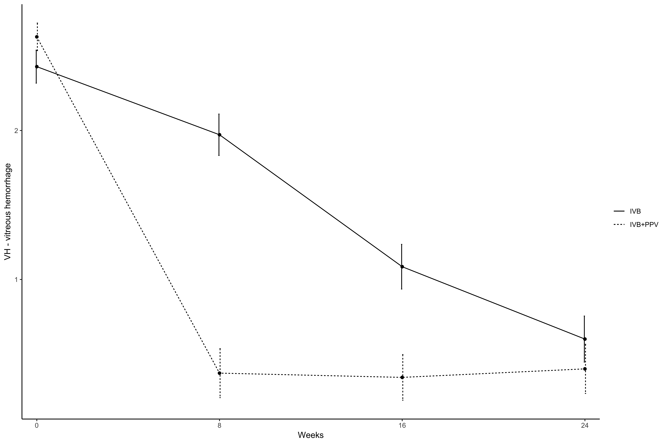

Figure 1. Vitreous hemorrhage score progression during the 24-week study period in both groups. Note the faster reduction in Group B score (submitted to *pars plana* vitrectomy) when compared to Group A (only intravitreal anti-VEGF injections). However, after 24 weeks, the mean score are similar in both groups.

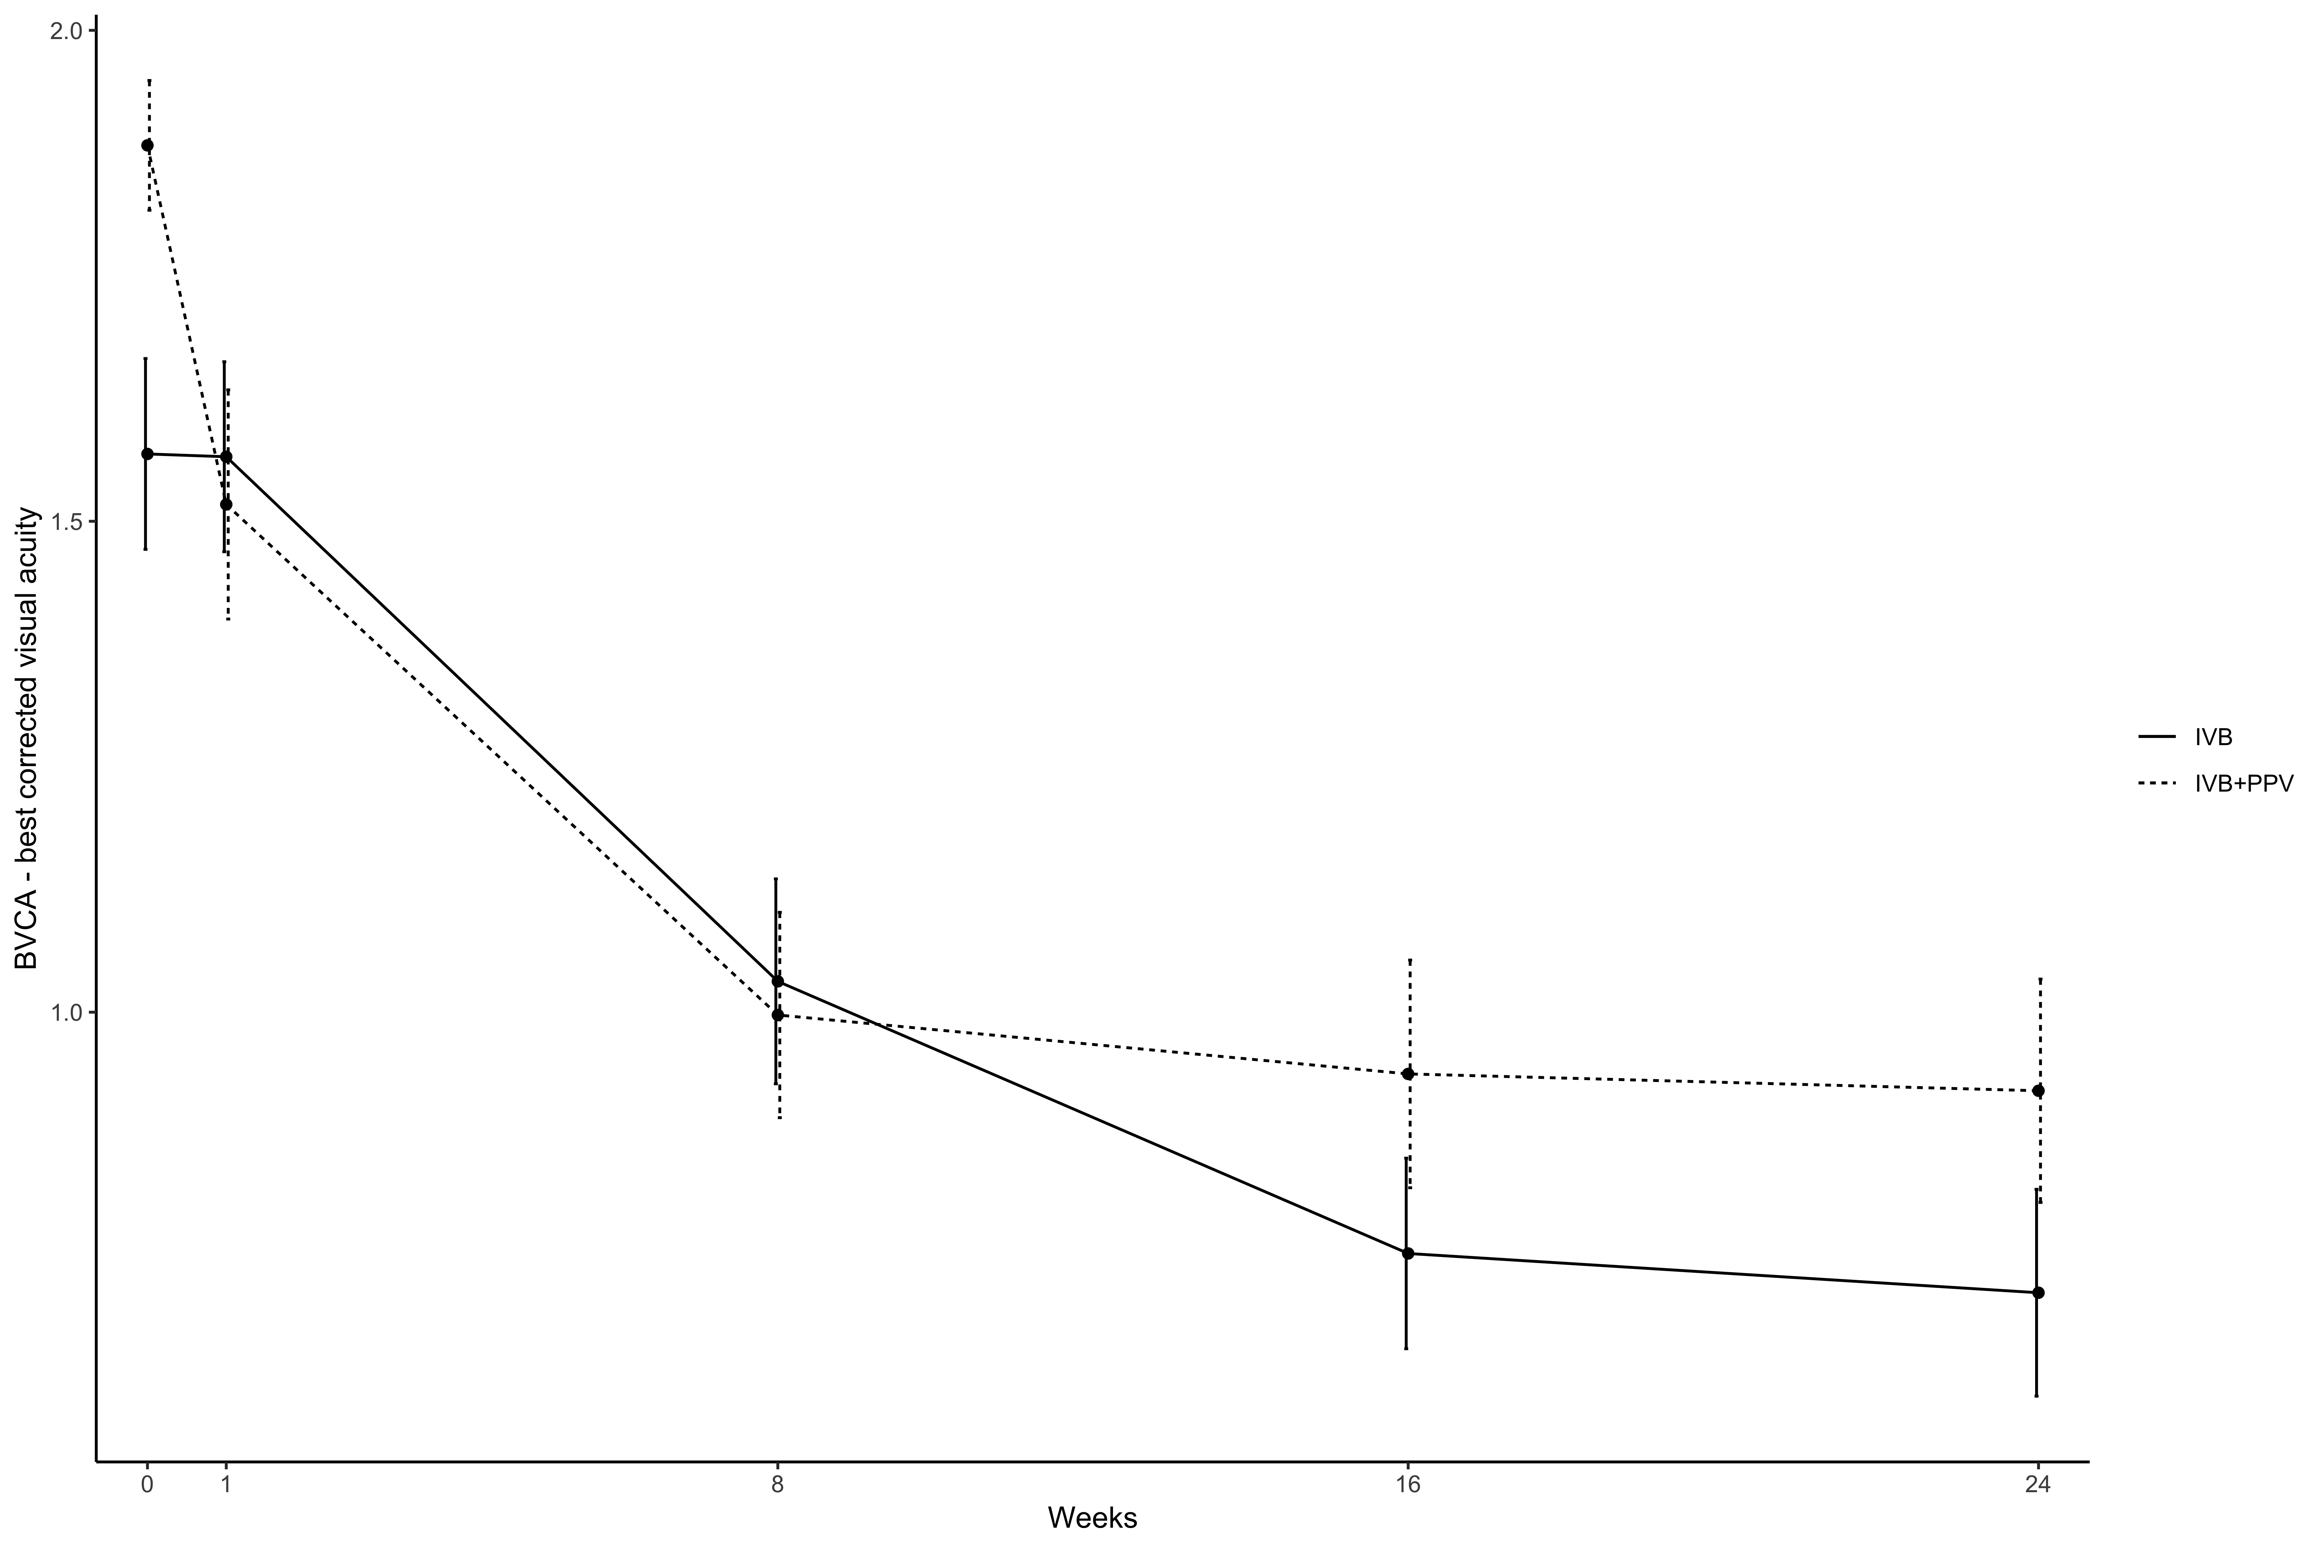

Figure 2. BCVA change progression during the 24-week study period in both groups. After one week of follow-up, there is significant improvement in BCVA only in the group submitted to pars plana vitrectomy (Group B). In the following visits till week 24, there was no difference in BCVA change between both groups.